Javascript to explore:

Let,var and const, Arguments, explicit and implicit parameter, …args, .

React:

library for creating user interface. React is a library.

Why React?

Virtual DOM

Reusable (and clearer) web components

Maintained by Facebook.

Hirable

React design concept: -

Components:

Like functions

Reusable and composable

Can manage private state

Reactive update:

React will react

Take update to the browser

Virtual view in memory:

Write HTML in javascript

Tree reconciliation

React component is of two types:

Function component

Class Component

class Button extends React.Component{

state={counter:0};

handleClick=()=>{

this.setState((prevState)=>{

return{

counter:prevState.counter+1

};

});

};

render(){

return(

<button onClick={this.handleClick}>

{this.state.counter}

</button>

);

}

}

ReactDOM.render(<Button />, mountNode);

class Button extends React.Component{

state={counter:0};

handleClick=()=>{

this.setState((prevState)=>({

counter:prevState.counter+1

}));

};

render(){

return(

<button onClick={this.handleClick}>

{this.state.counter}

</button>

);

}

}

ReactDOM.render(<Button />, mountNode);

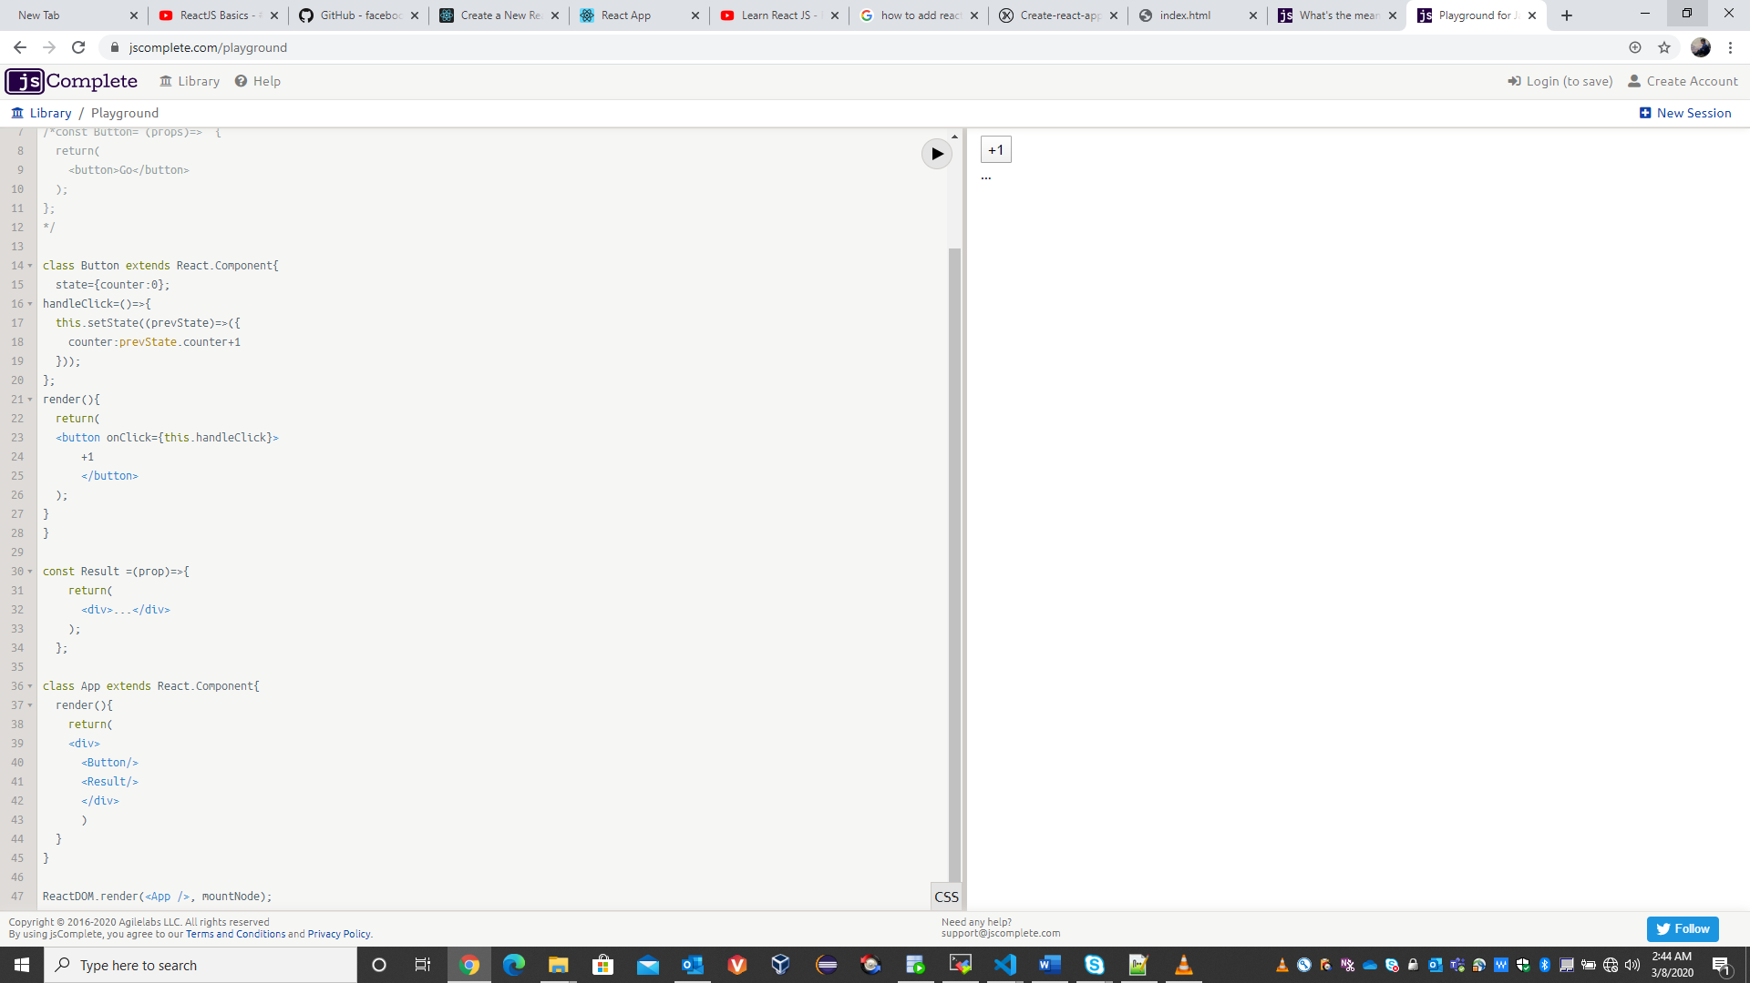

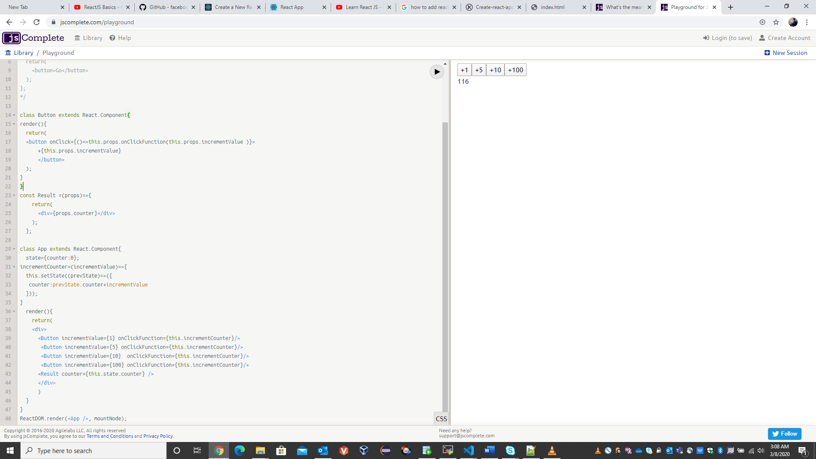

Or another alternative here is use to bind function and create new function that remember the arguments but not the recommended way to handle this situation because when we use the bind method or the function wrapper method were actually creating a new function for every rendered button and that should be avoided instead can use the previous handleClick method like below:

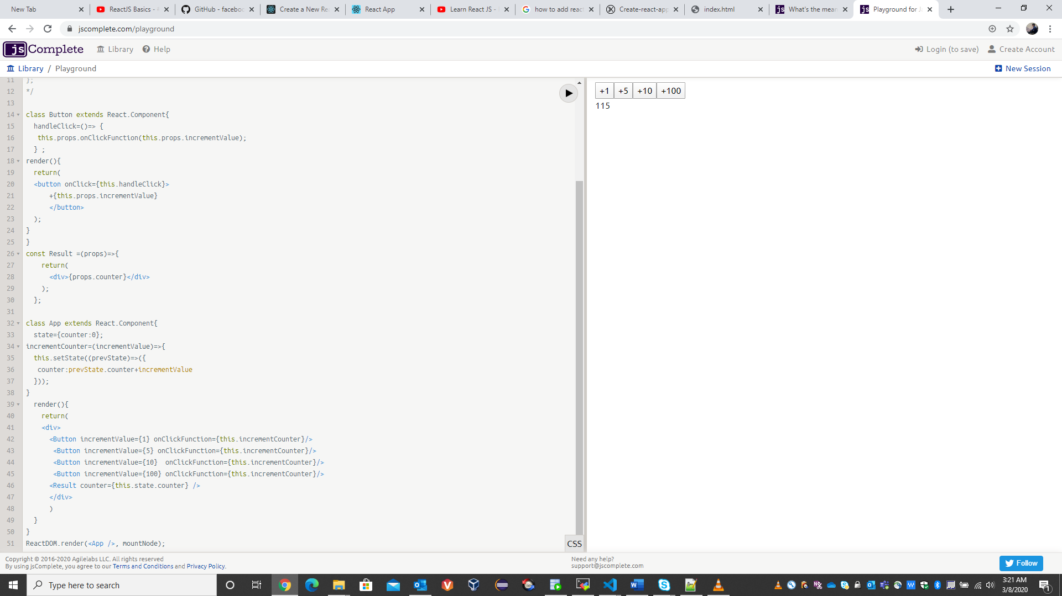

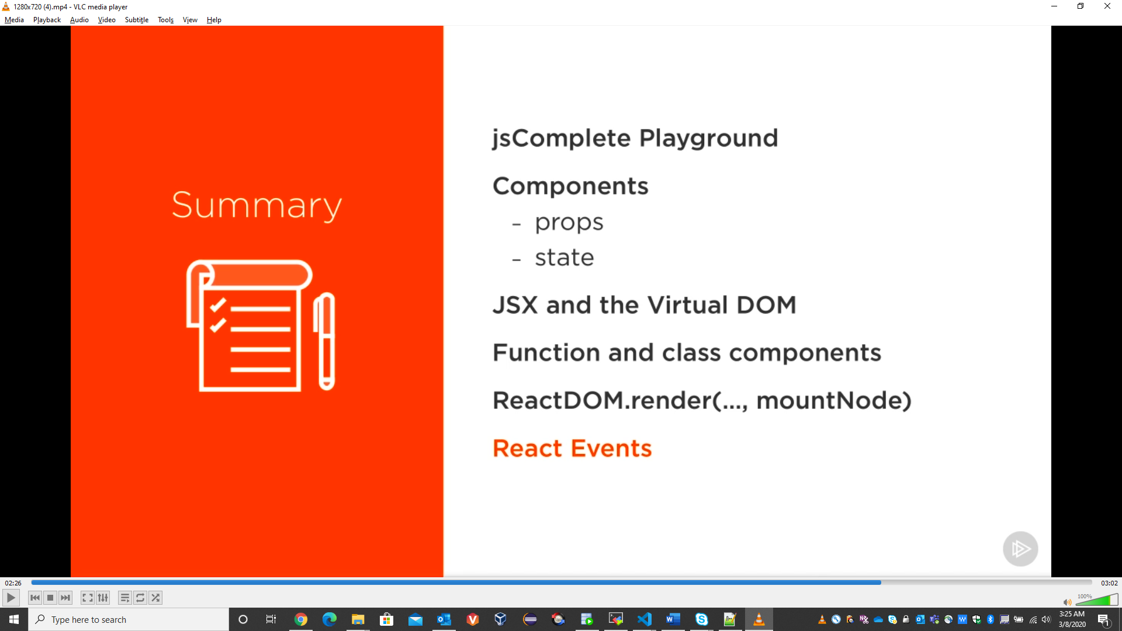

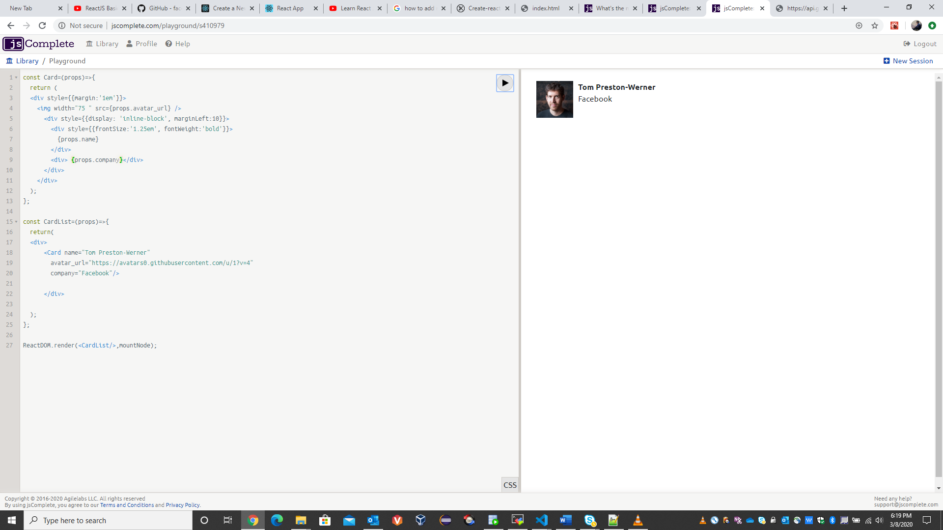

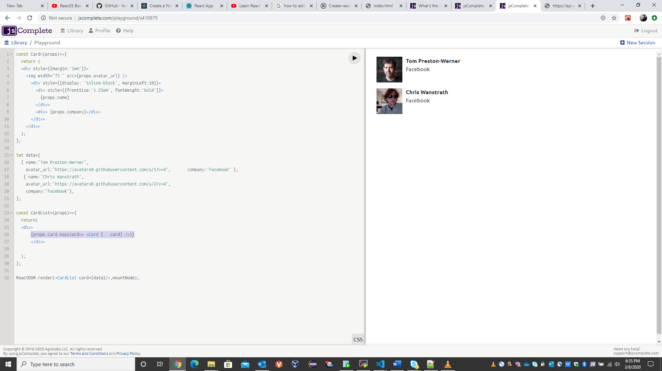

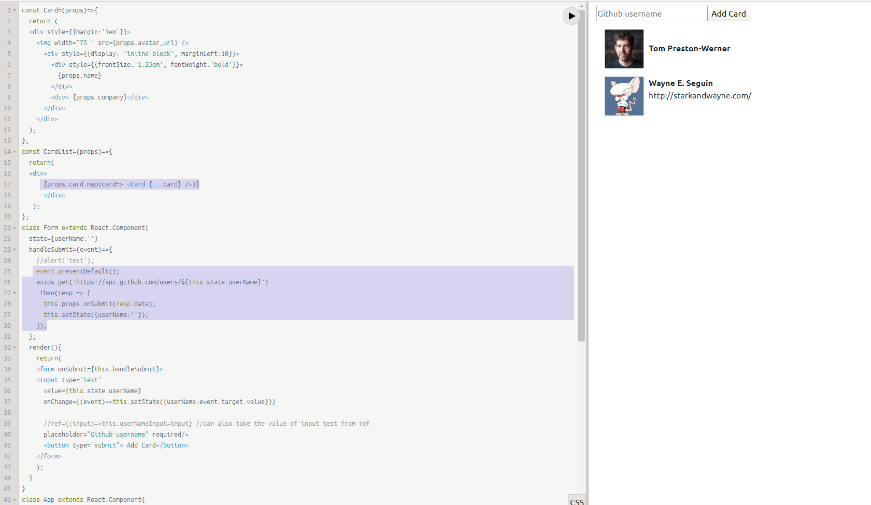

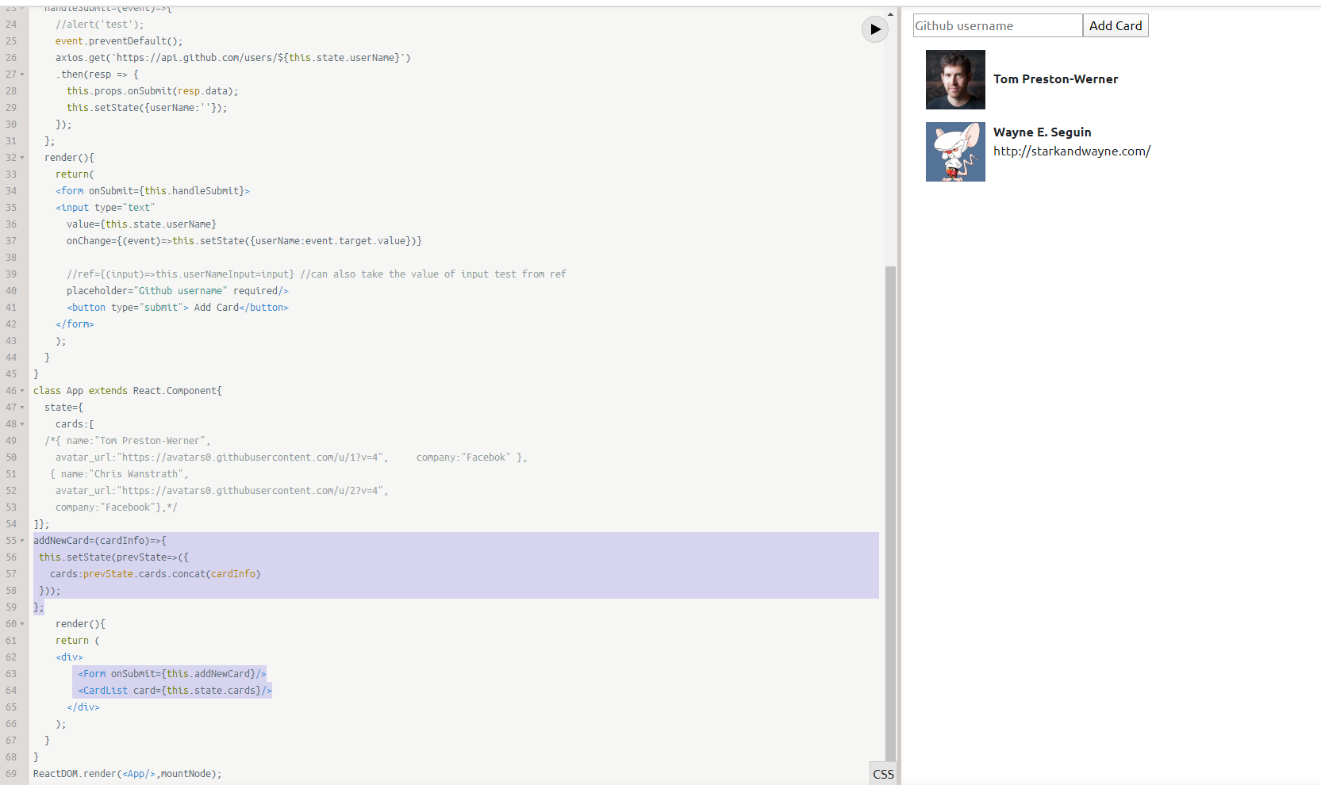

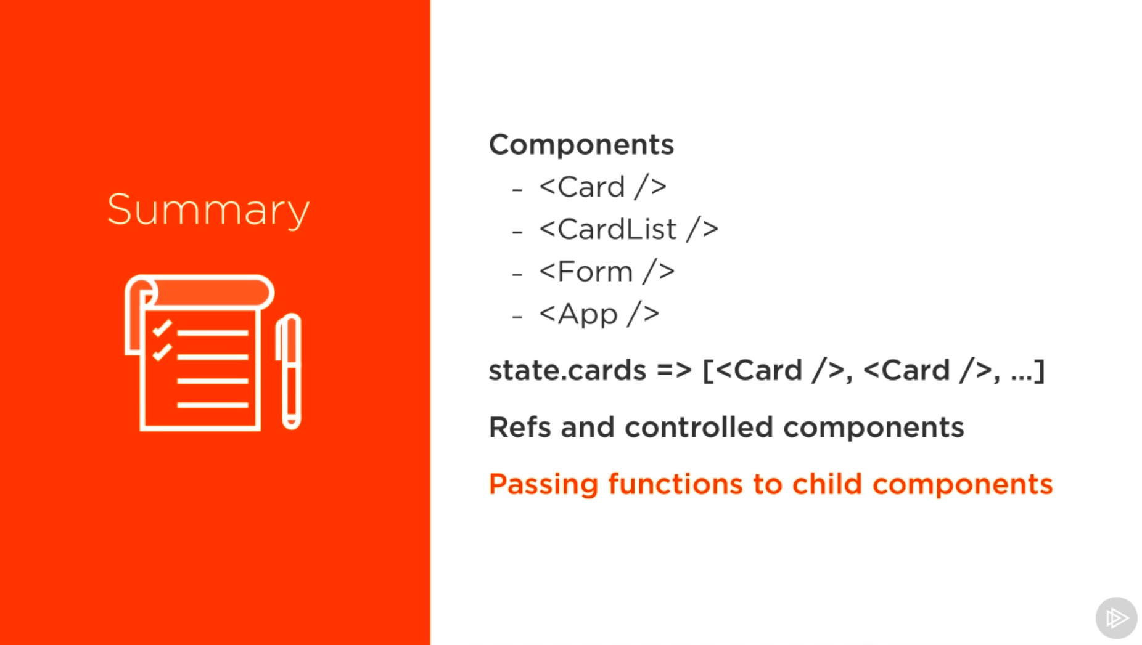

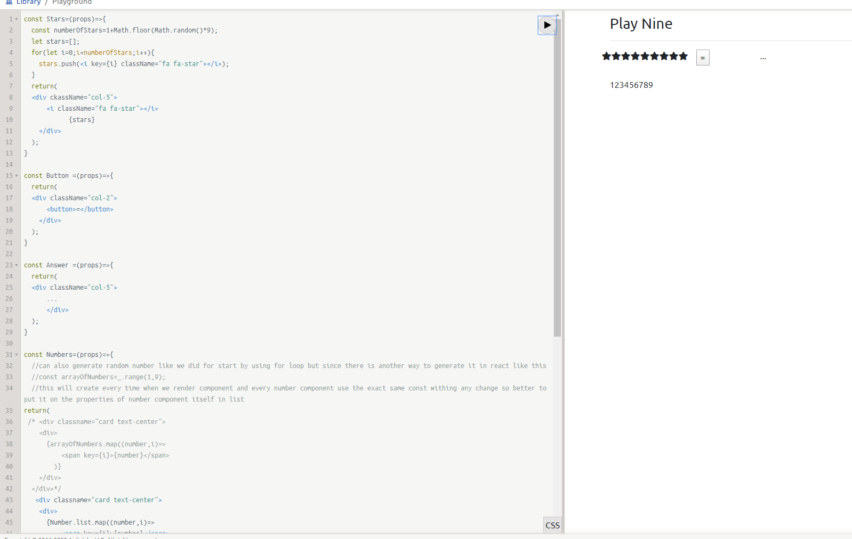

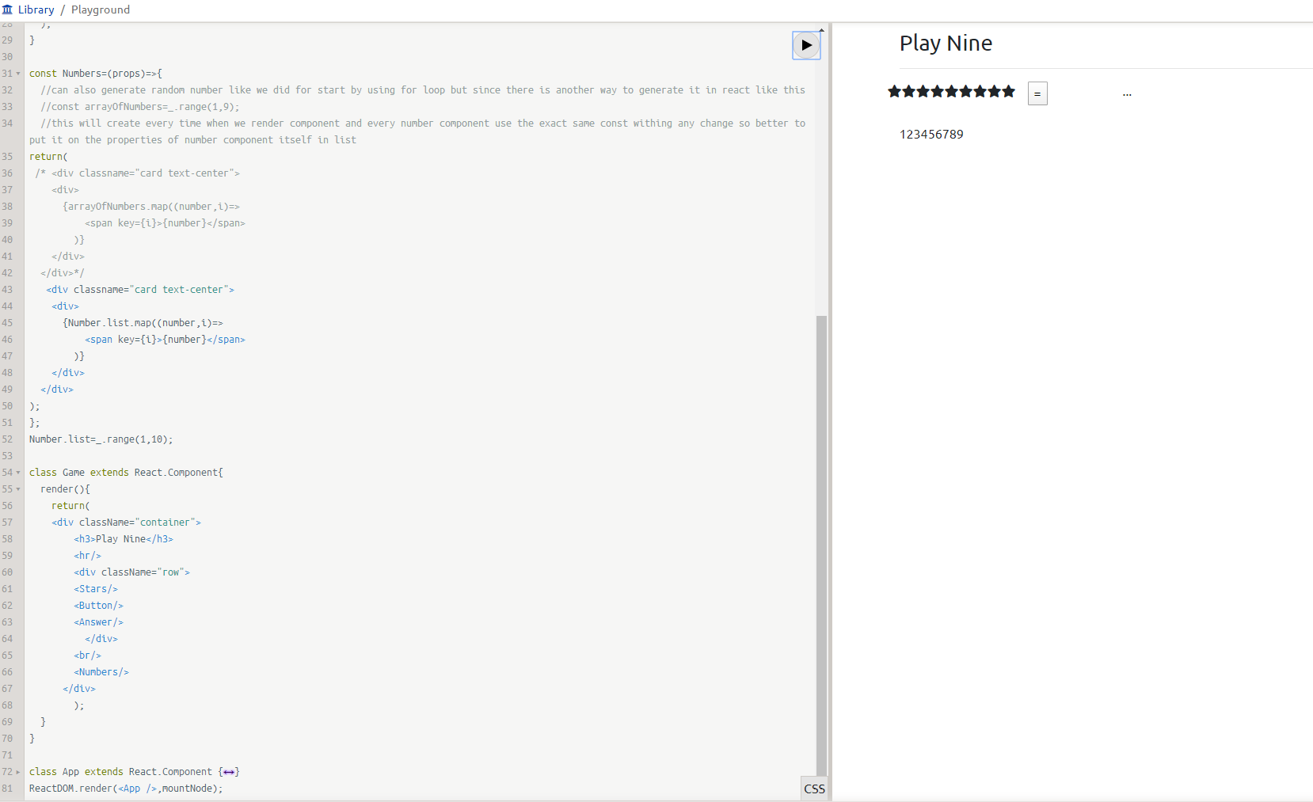

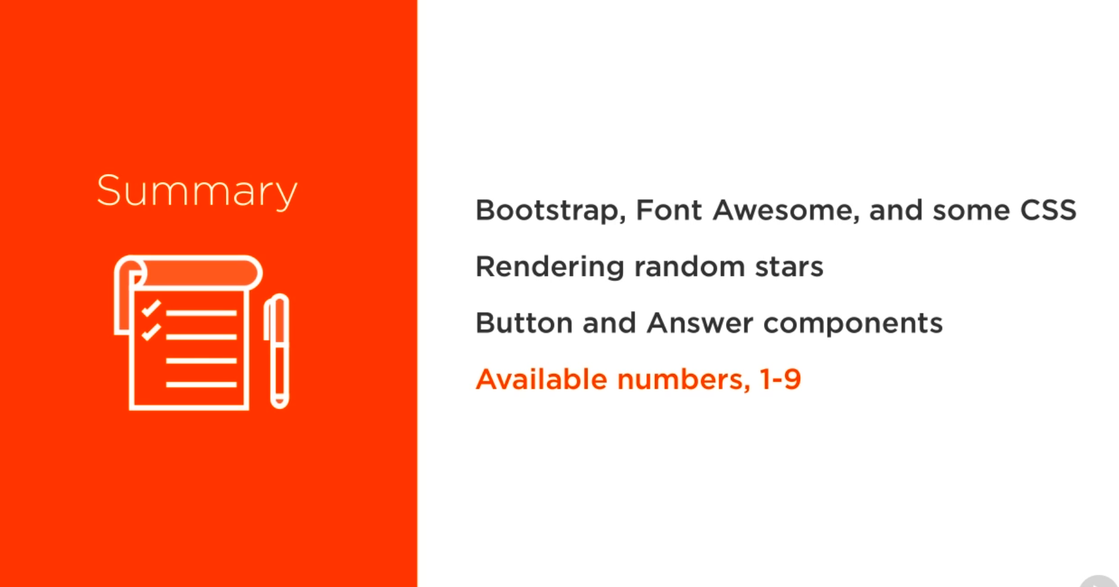

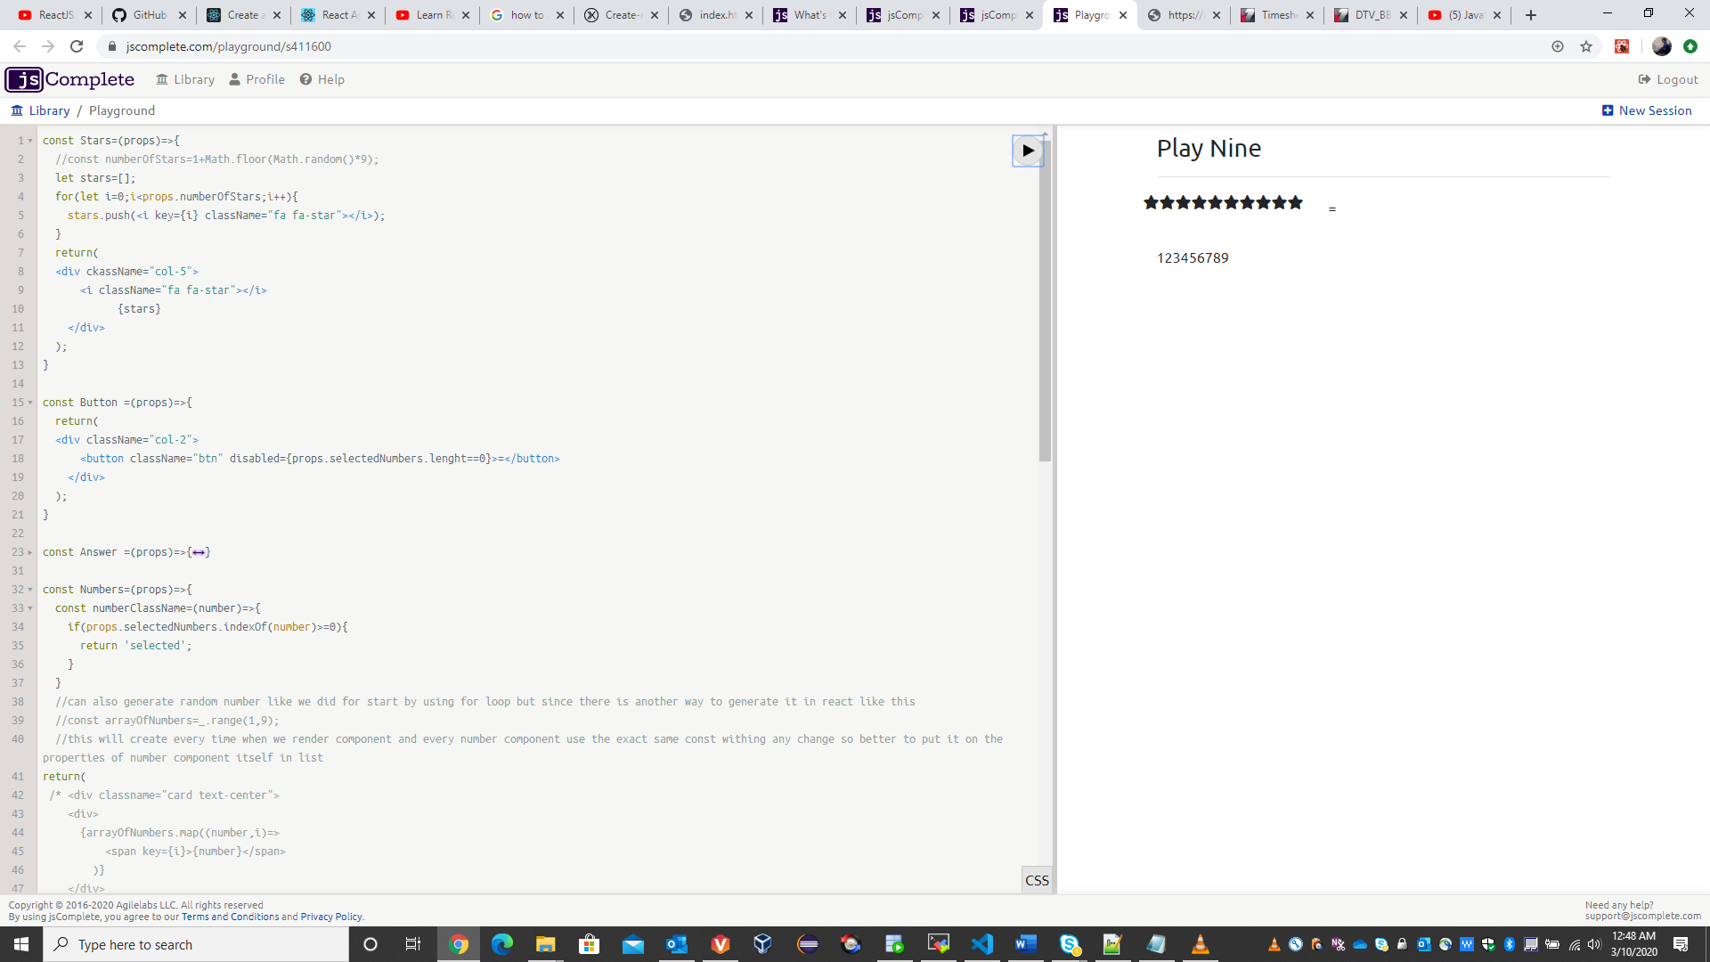

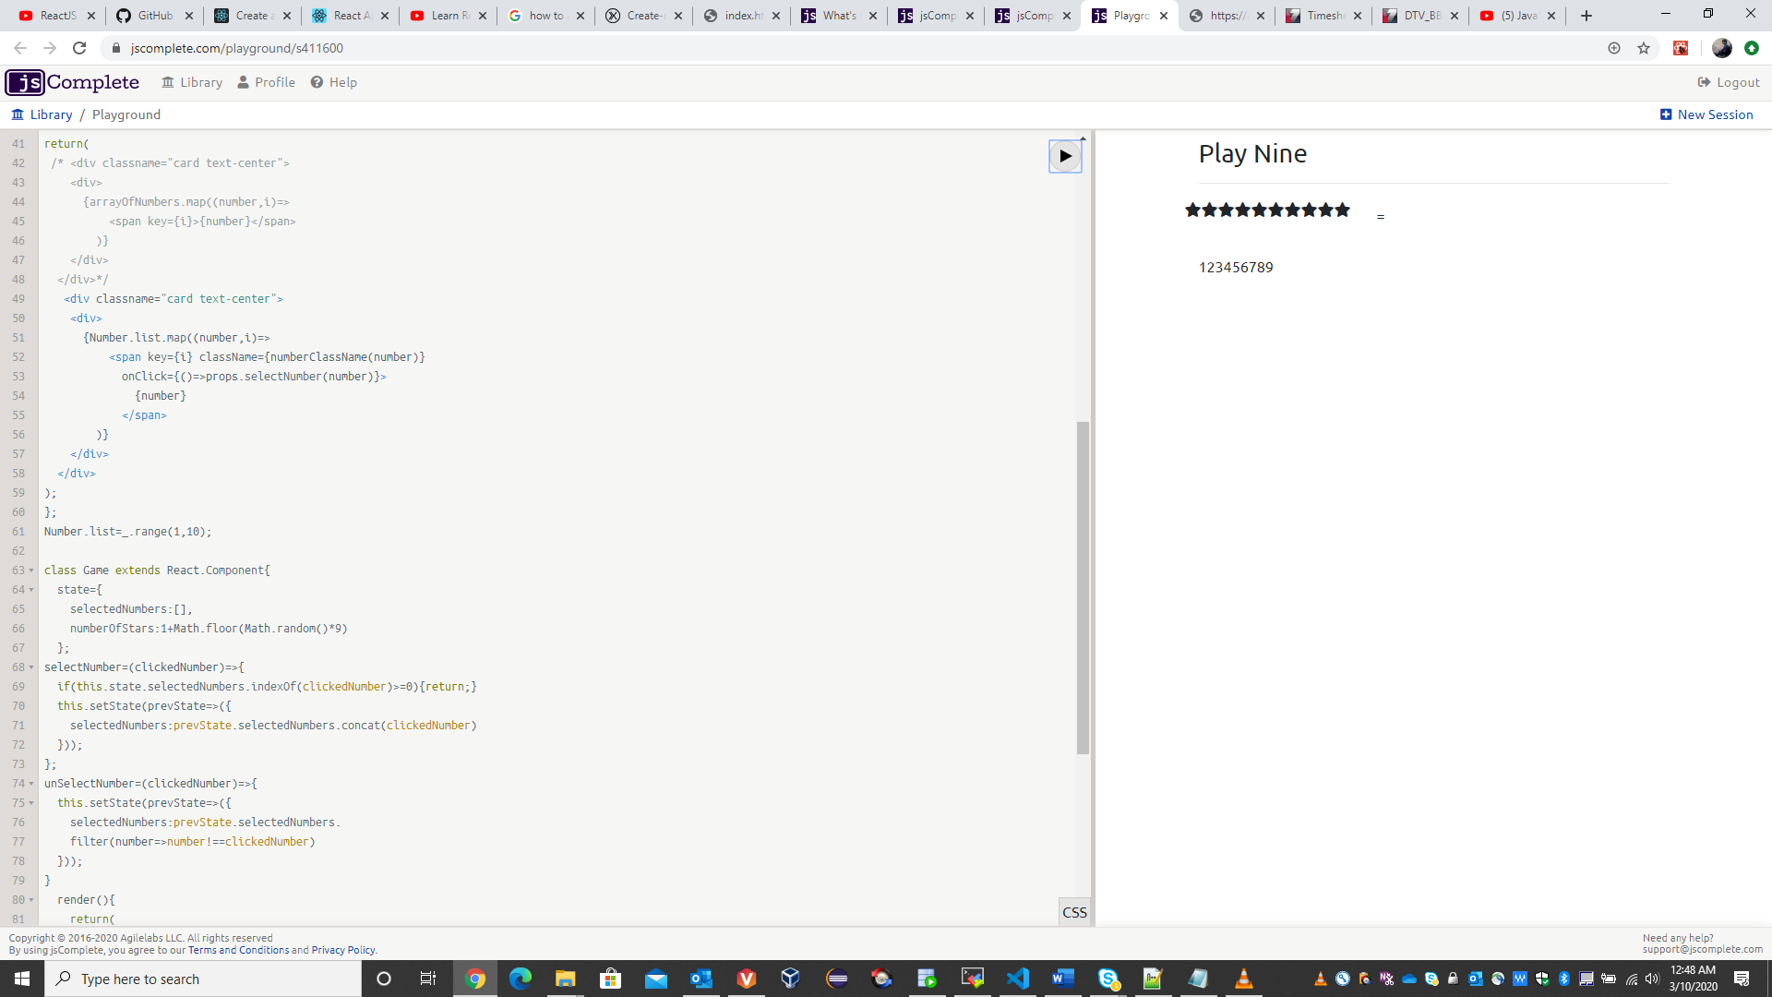

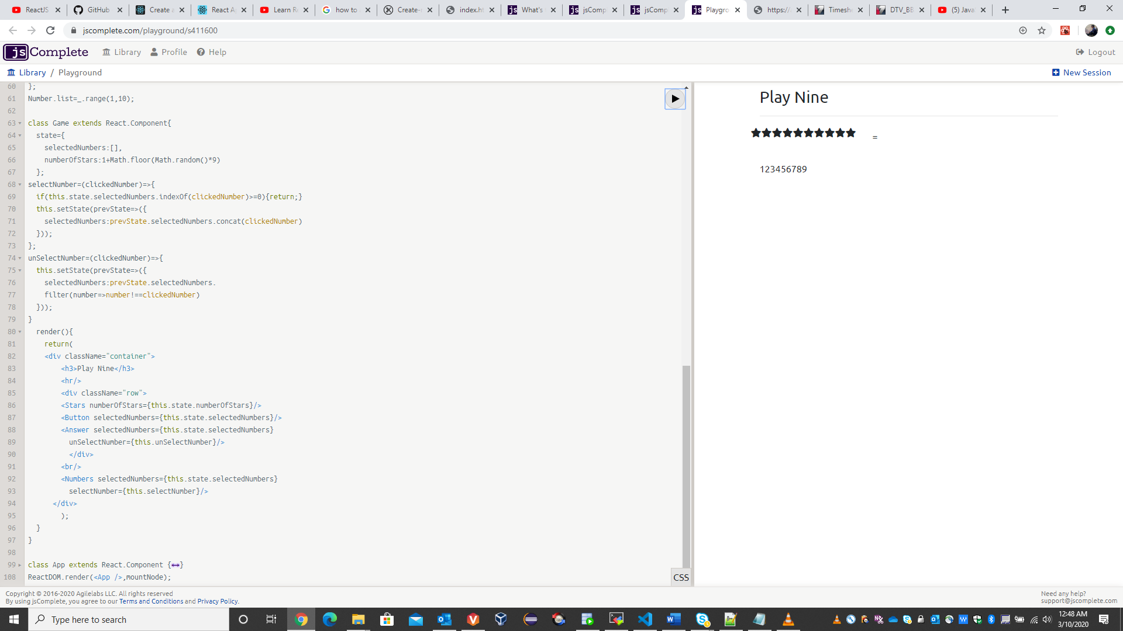

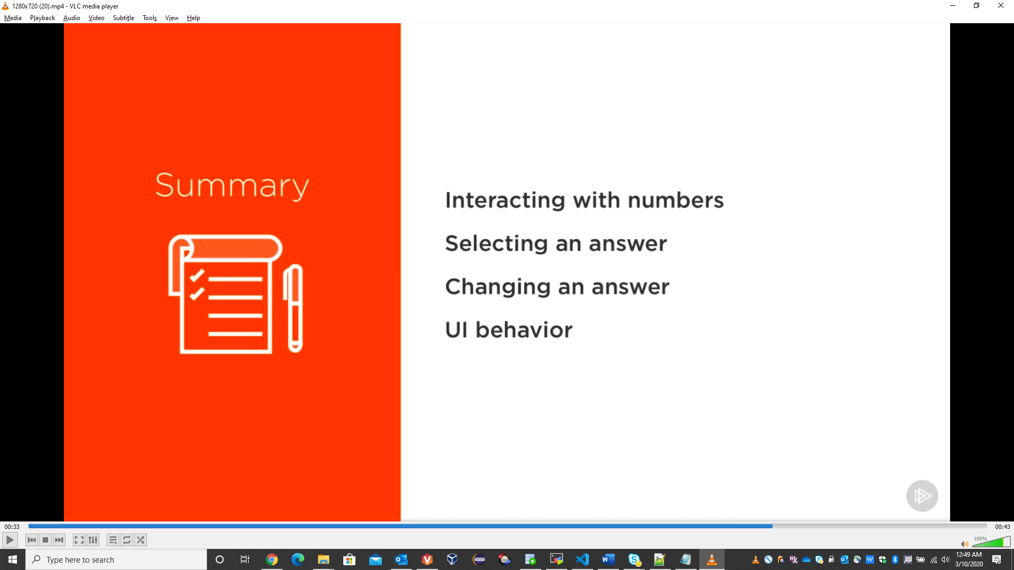

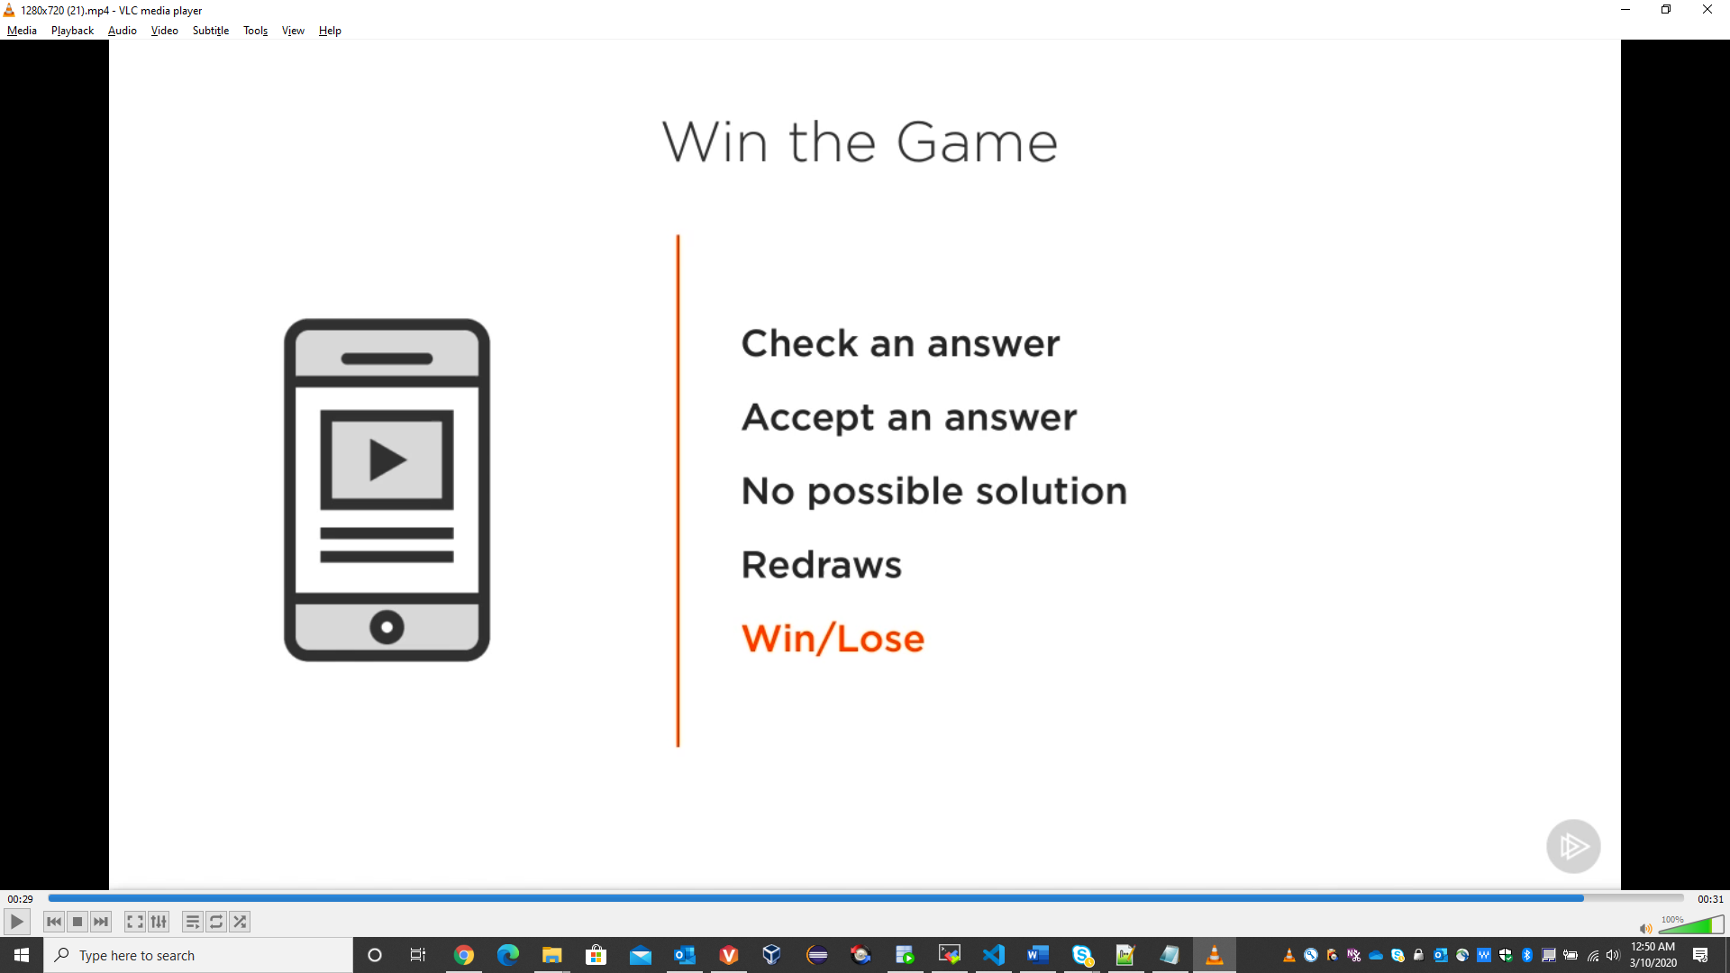

# Components

Component is usually place in js file with .js or .jsx extension.

Types: -

1. Stateless functional component: JavaScript function which return html, describes the UI.

2. Stateful class component: ES6 classes which extends Component class form react library, they must contain the render method which return html.

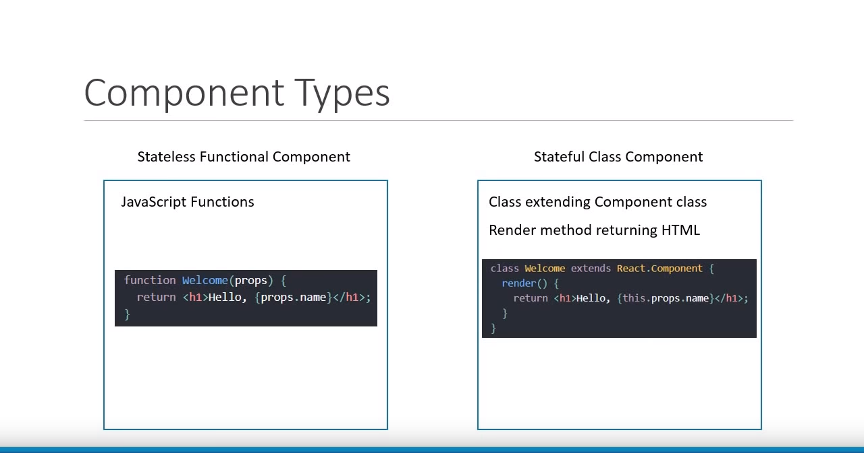

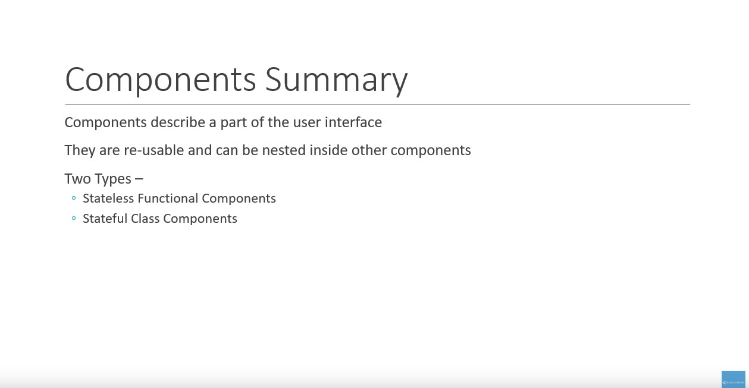

## Functional component

Functional component is a JavaScript function that accepts an input of properties(props) and return HTML code (JSX) which describes the UI.

**Note: - export default Greet; allows to import Greet to any other file with any name. BUT if we export as name then it is compulsory to import it with the same name. like:**

**Name Export: - export const Greet= () => <h1>Hello Ujjawal</h1>**

**Syntax to import name export: - import {Greet} from ‘. /Component/Greet';**

Greet.js

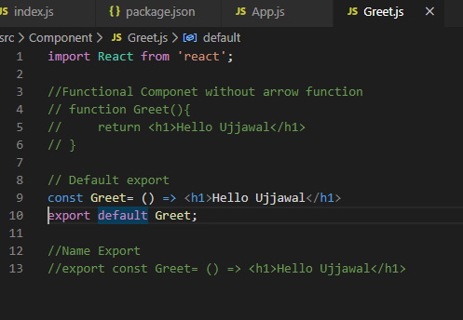

App.js:

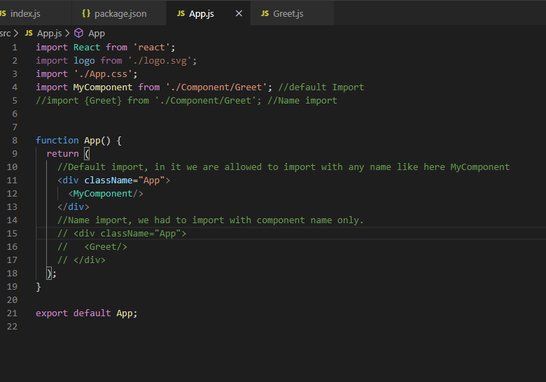

## Class Component

Class Component is an ES6 classes which can also take props(optionally) as input and returns HTML(jsx) as output. Apart from the props, class component can also maintain internal private state i.e it can maintain some info which is private to that component and use that info to describe user interface.

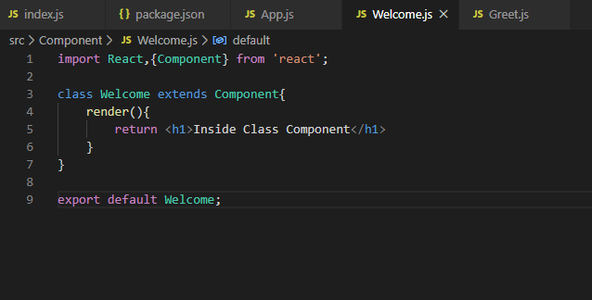

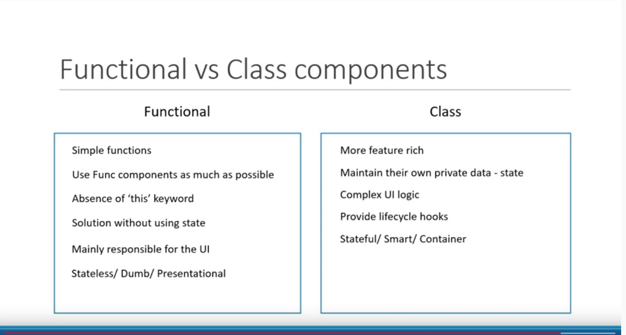

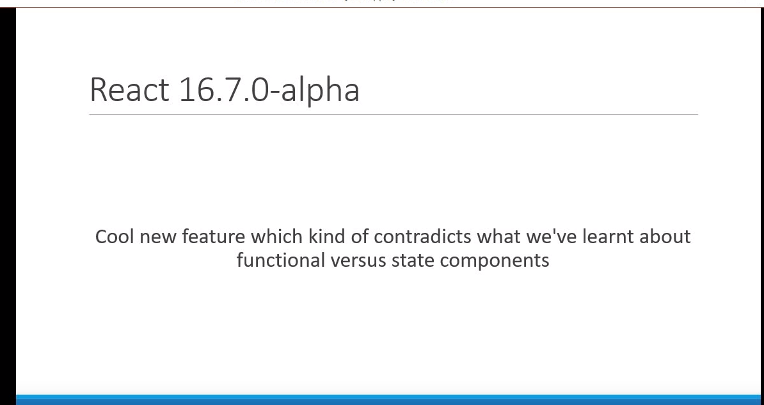

**React v16.7 onwards functional component will also have state called Hooks like class component.**

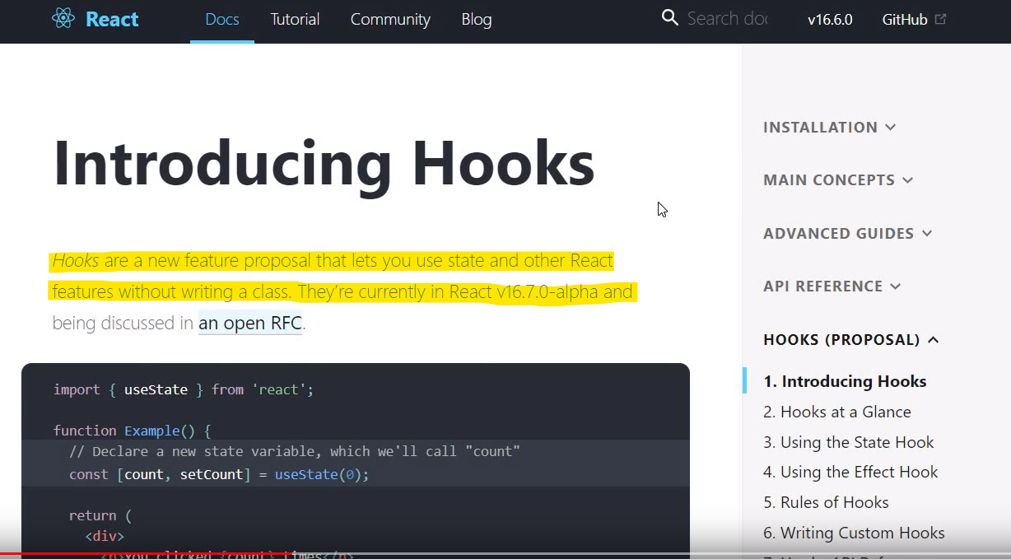

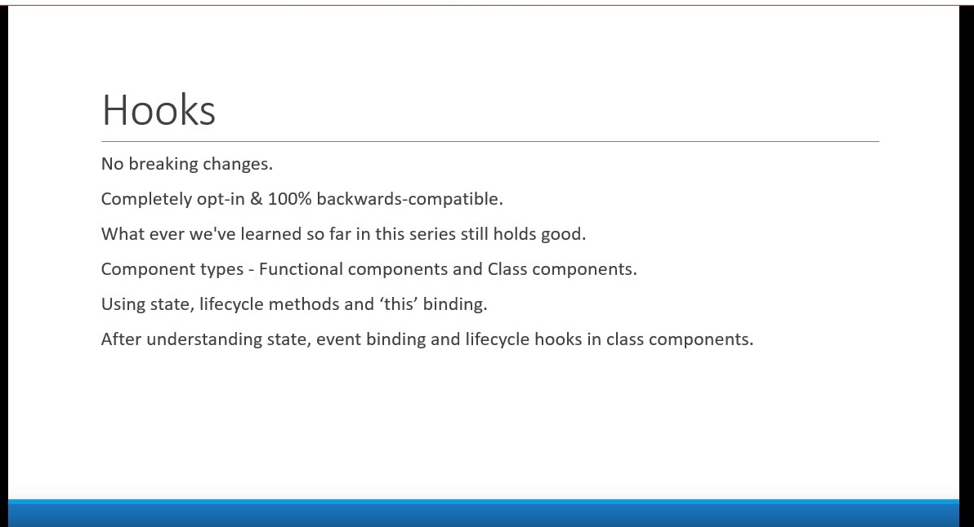

# JSX

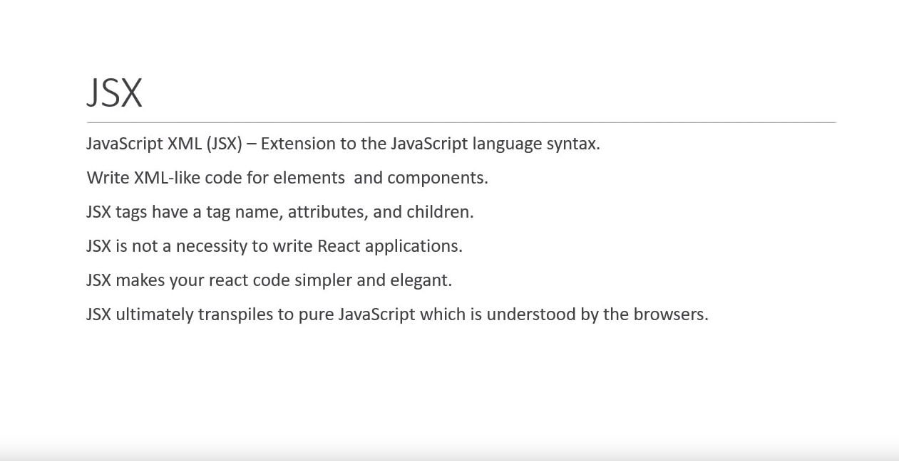

JSX is a syntactic way of calling createElement method of React, that’s why always import React. It takes 3 args- 1) tag name, 2) key value pair property like id, class etc., 3) text like

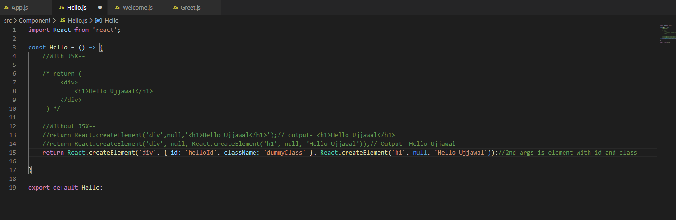

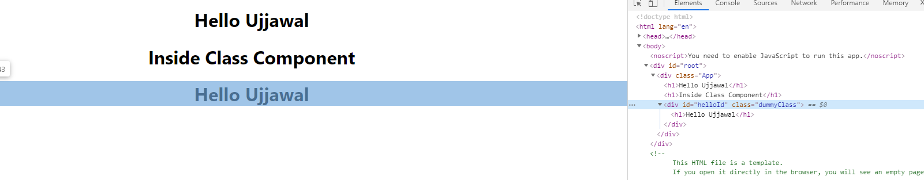

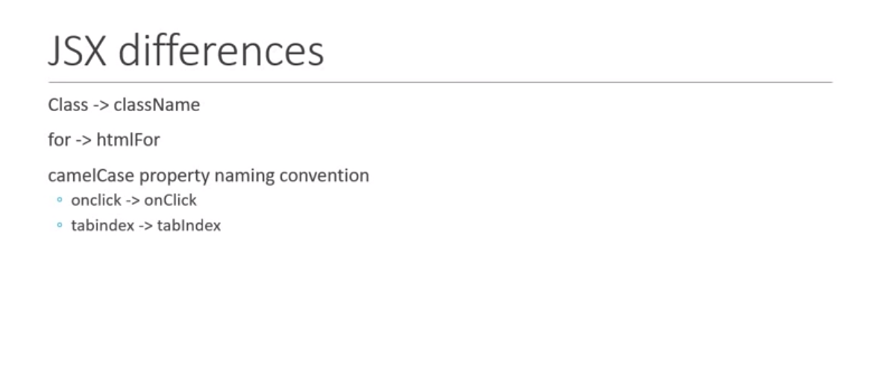

**Props are immutable i.e their value cannot be changes it means we cannot assign value in props like:**

**Props.name=’NewName’ // error**

**In functional component property value can we used by {props.propertyName} whereas in class component property value can be used by {this.props.propertyName}.**

**{props.children} is used to access the value that pass between the tag like**

**<Hello>*hello I am children*</Hello>**

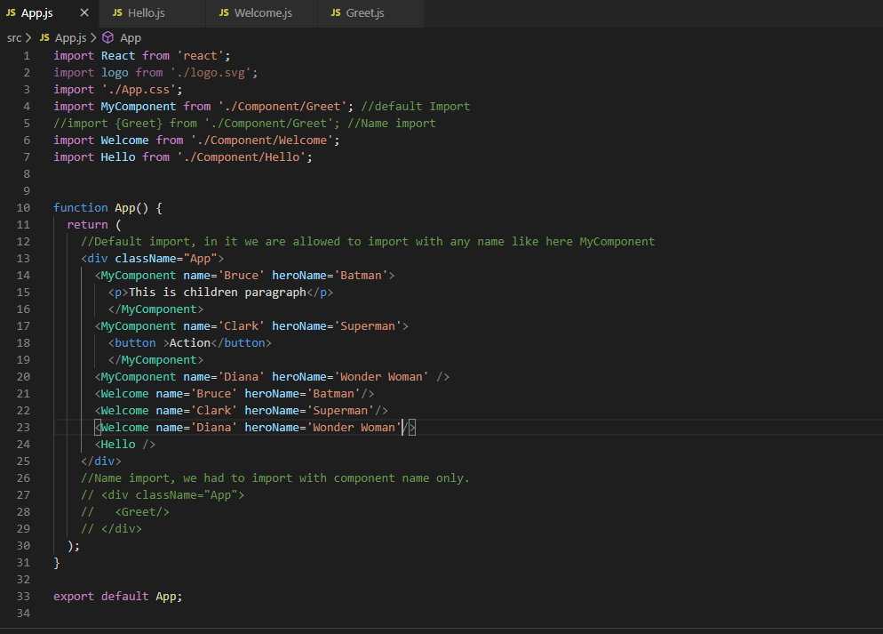

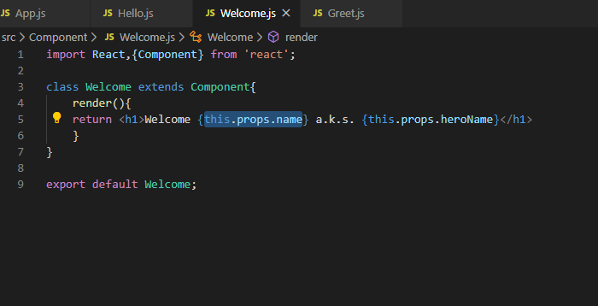

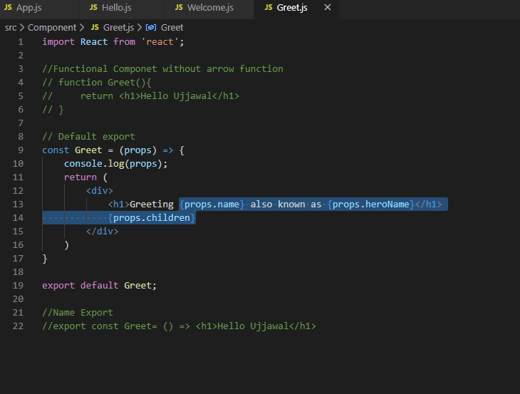

# State

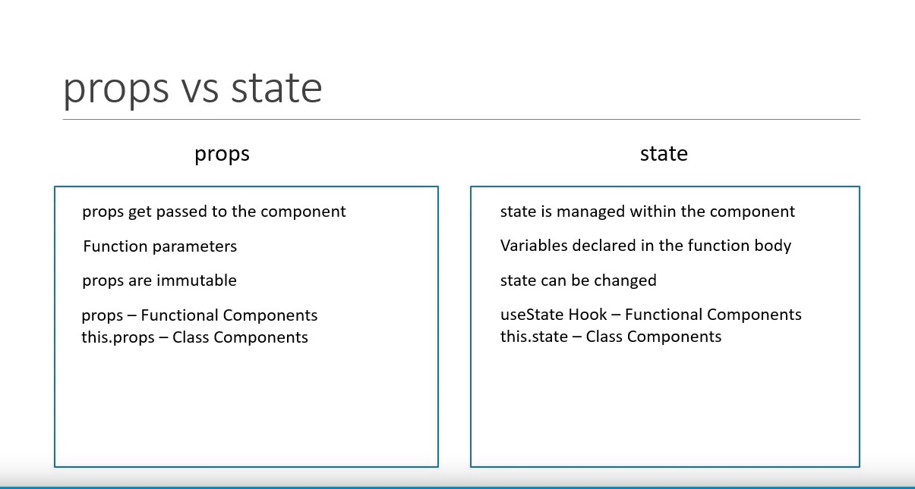

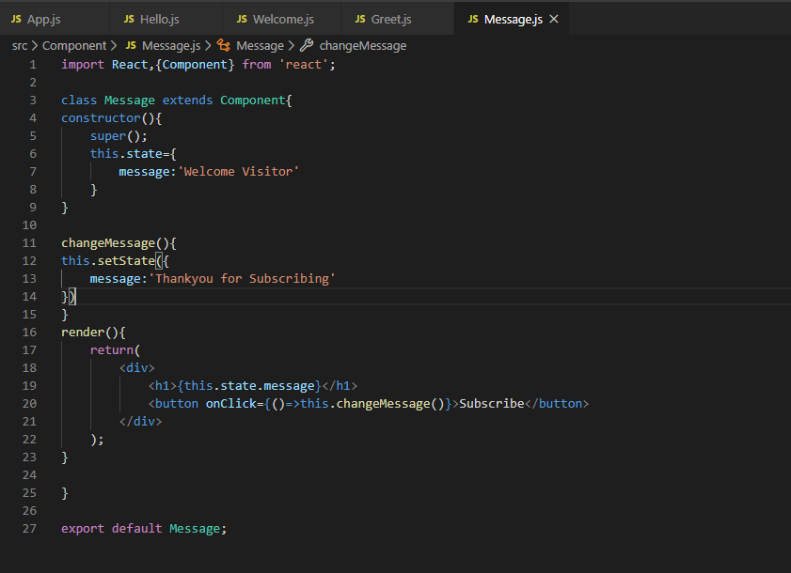

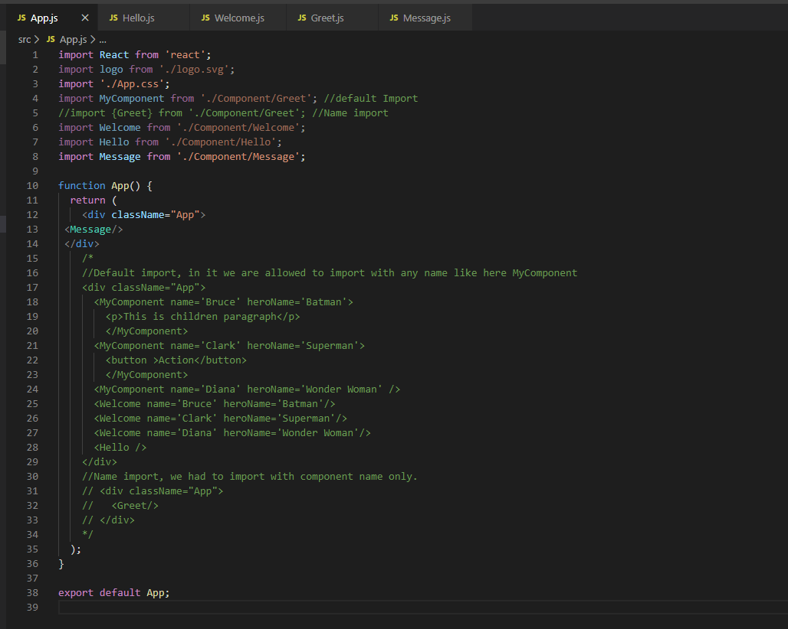

**Never modify the states directly always use setState() method**. If we do without setState then it updates the variable value but won’t bind (re-render) the component to UI, we can test this by adding console.

**setState() is an asynchronous function** so to make it synchronous add the callback function in 2nd argument. Whenever we have a requirement to execute the code after state is set use callback method don’t put the code outside setState() method. Like in below example 2nd console.log(outside setState method) is printing before setState method and 1st console.log(inside callback method) is printing after setState method.

If we have a requirement to update the state based on previous state, then use prevState and pass a function argument in setState() and update state object using prevState instead of using regular object. The function that passed in setState() has access to get the previous state by using prevState which can be used to calculate new state.

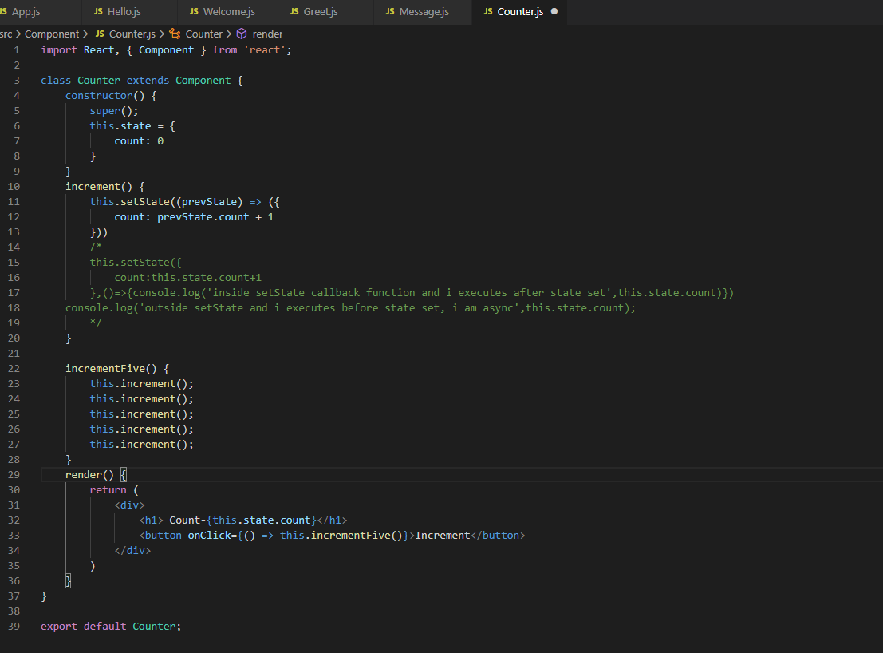

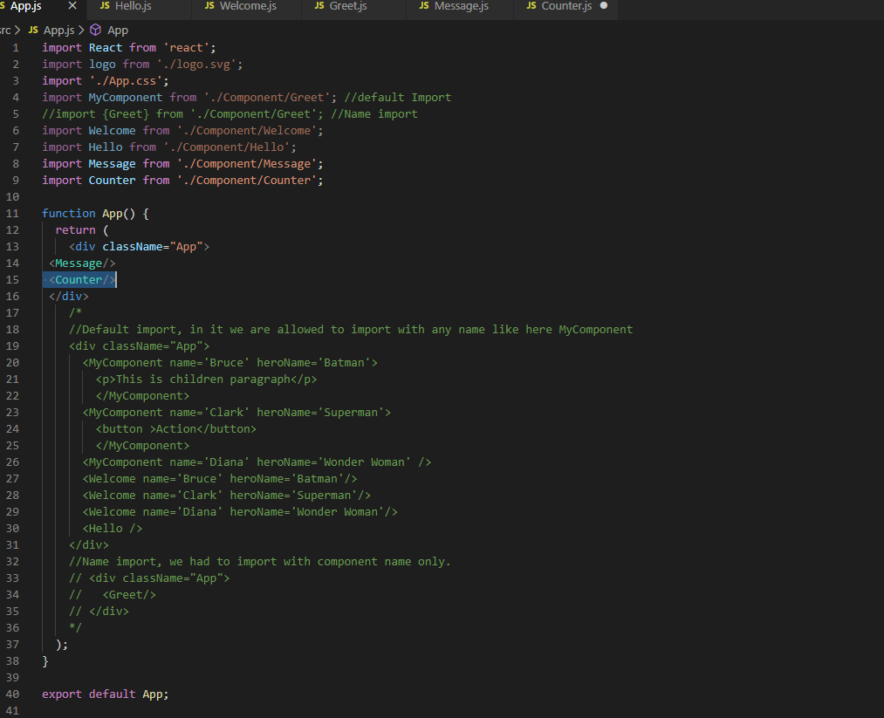

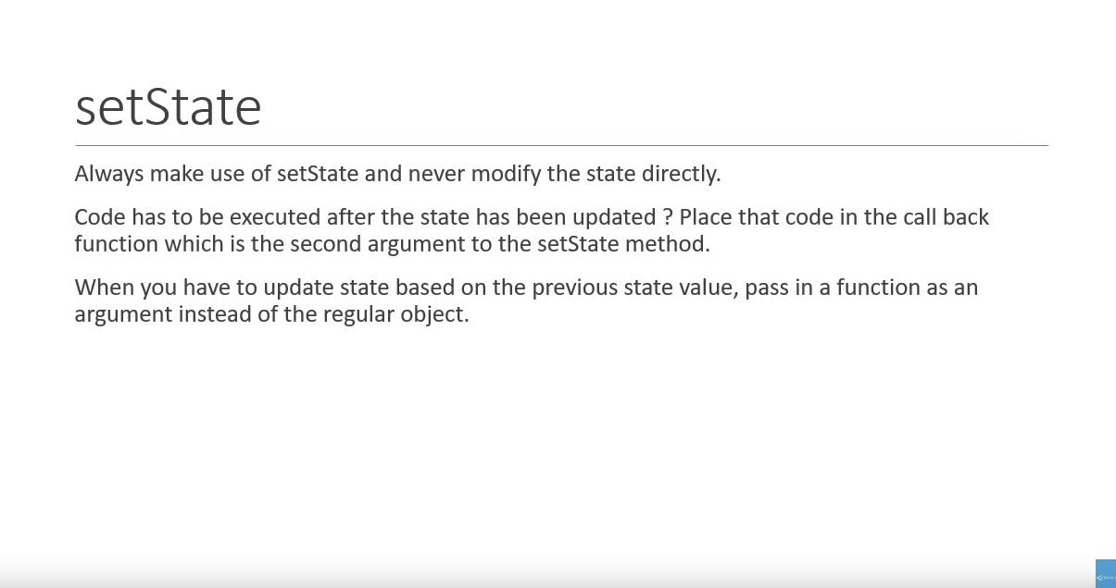

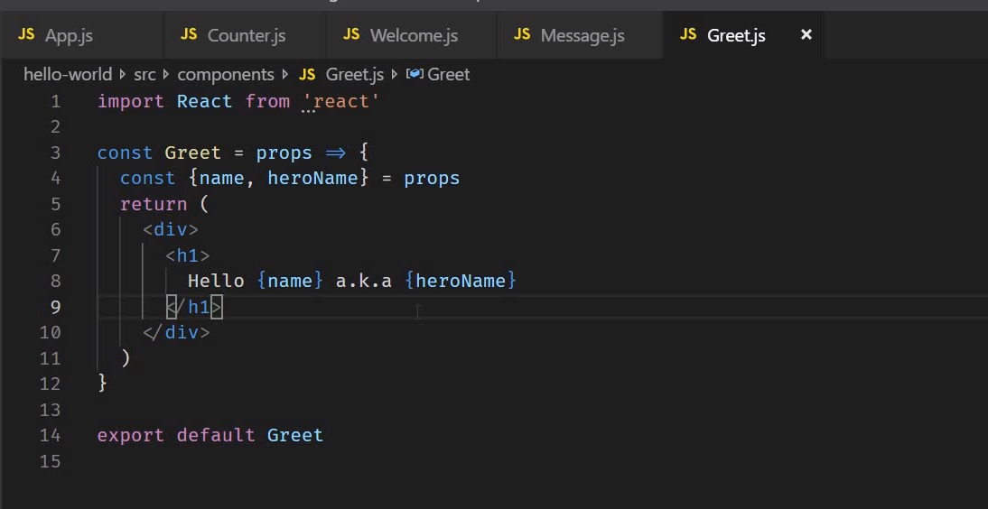

# Event Handler

Event should always in camelCase and in event handler is a function not a function call, so do not add parenthesis. For Functional component handler should be called without this keyword but in class component it is mandatory to mention this before writing handler.

onClick={clickHandler()}—wrong

onClick={clickHandler}—functional component, correct

onClick={this.clickHandler}—class component

## Event Binding

“This” keyword is undefined in the event handler that is the reason event binding is necessary in react class components.

Ways to bind event handlers in react: -

1) use bind keyword and bind the event handler in render method.

<button onClick={this.clickHandler.bind(this)}>Click</button>

2) Use the arrow function in render method and return clickHandler method from that. In below example curly braces and return keyword is not used because there that is single statement.

<button onClick={()=>this.clickHandler()}>Click</button>

3) Binding the event handler in class constructor instead of binding in render method.

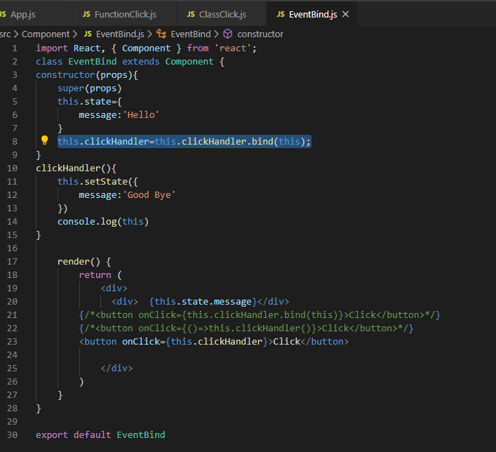

4) Use arrow function as a class property. Basically, we will be changing the way we define event handler in the class.

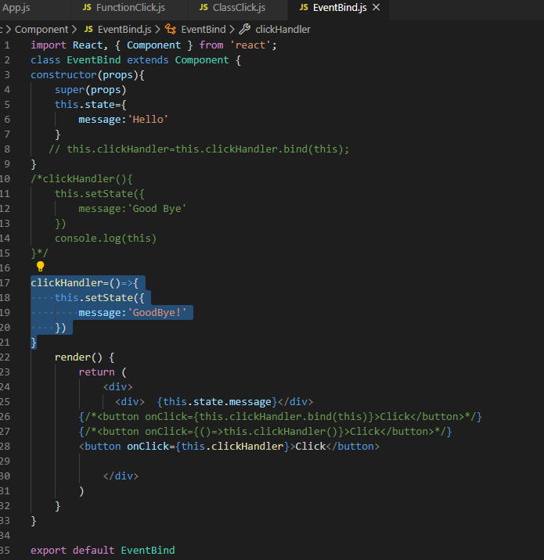

**Note: - First and second approach is not suggested due to performance issue. And third and fourth approach is suggested in React documentation also.**

# Calling Parent component from child Component (methods as props)

We also use props to call parent method from child component. Add Parent Component in App.js

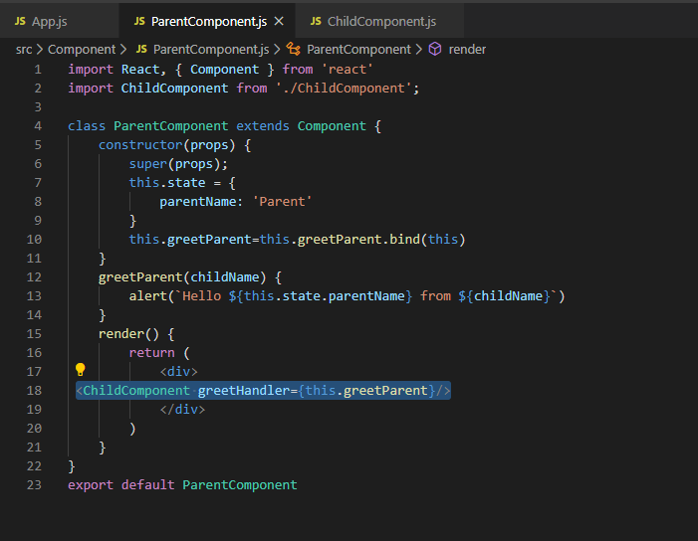

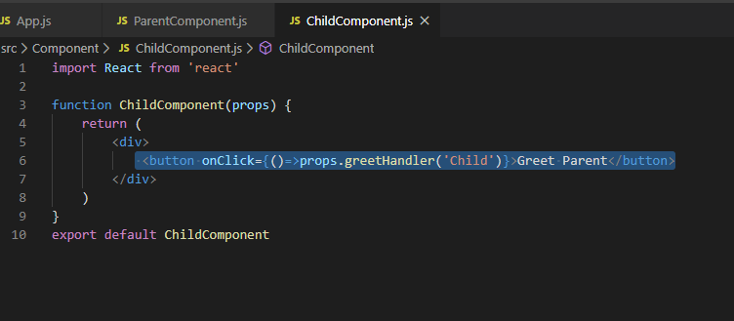

# Conditional Rendering

Hide or show html based on certain conditions. Four different ways to implement conditional rending in react: -

1) if-else

2) Element variables

3) Ternary conditional operator

4) Short circuit operator-it’s specific case of ternary operator (render either something or nothing) if left side of short circuit operator is true it evaluates right side and return it else doesn't return anything.

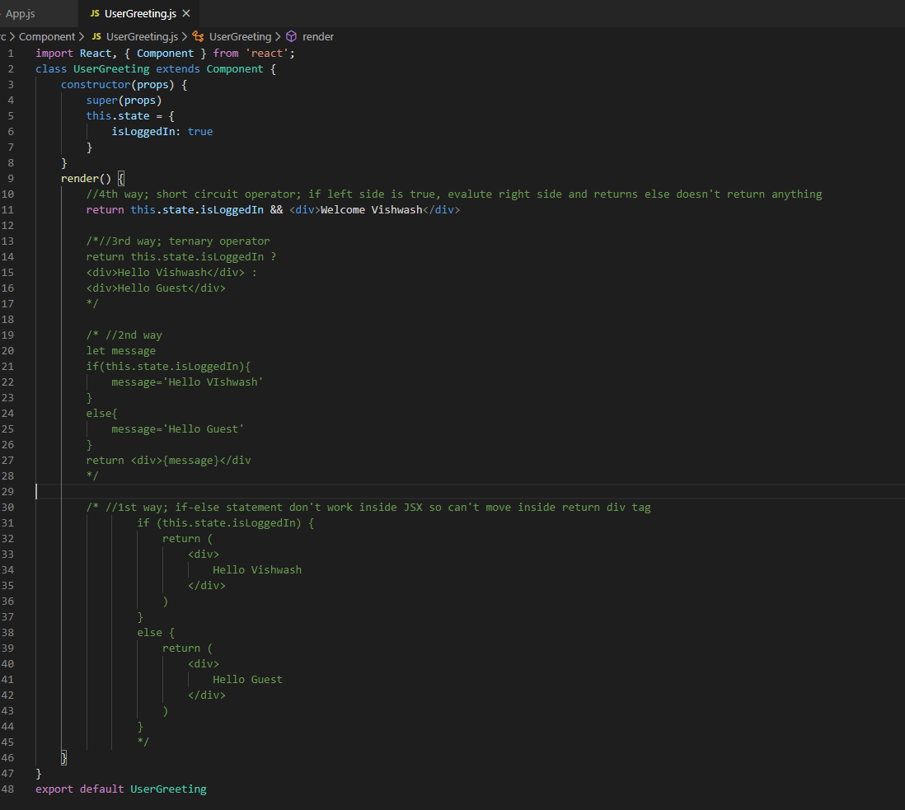

# List Rendering

To render list, we use JavaScript “map” method.

It’s recommended to keep List and render component separately like NameList.js (store list of person) and Person.js (responsible to view list on browser). Add NameList component in App.js

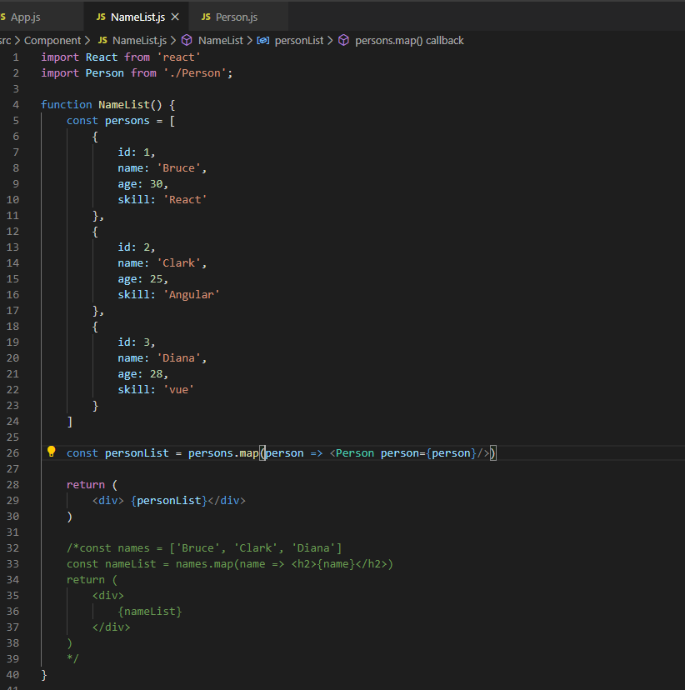

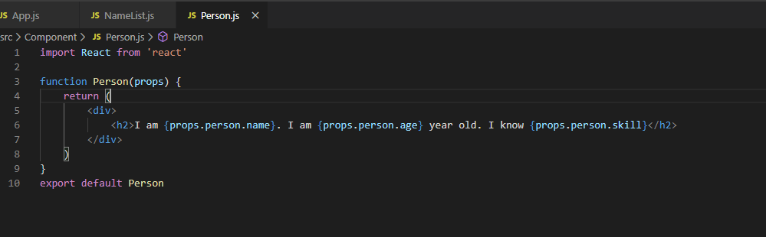

But in above code browser shows the warning that each child should have a unique “key” props, Why?

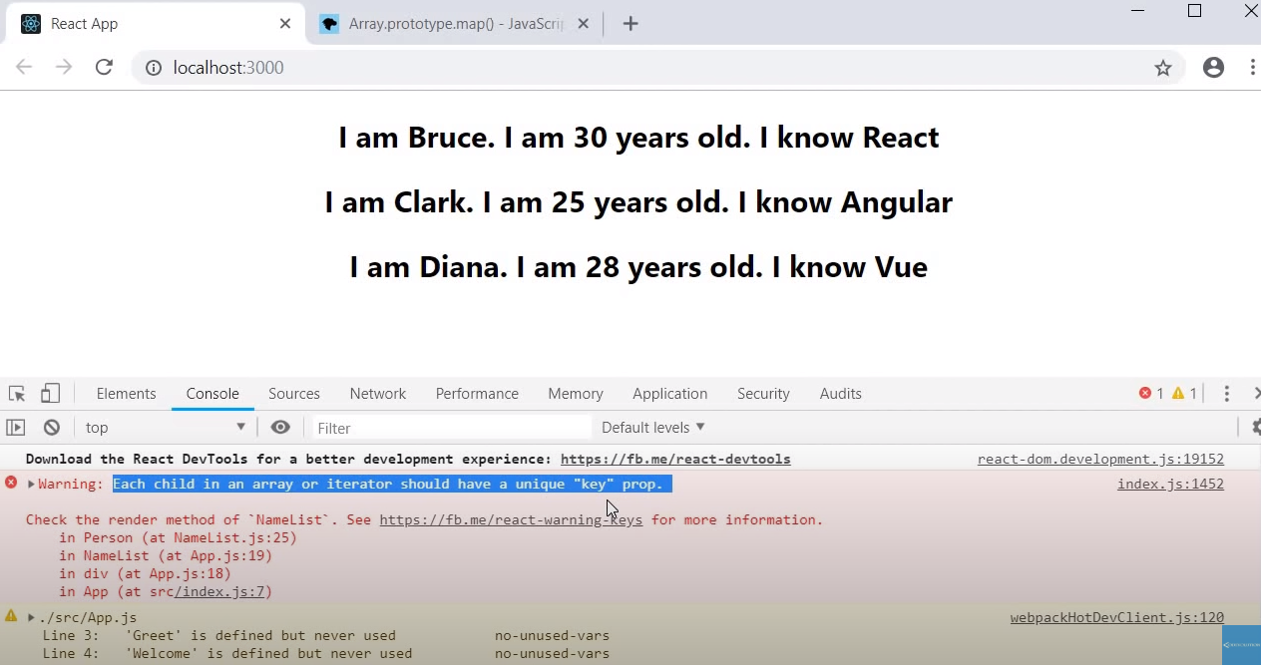

Warning says each item in the list rendered using map operator should have a prop called key and the value to the prop should be unique within the list.

To add a key prop, we need to make change in the code and assign the value to the key that will be unique in the list. Since in above example id is the unique among all the list so we can assign id as a key.

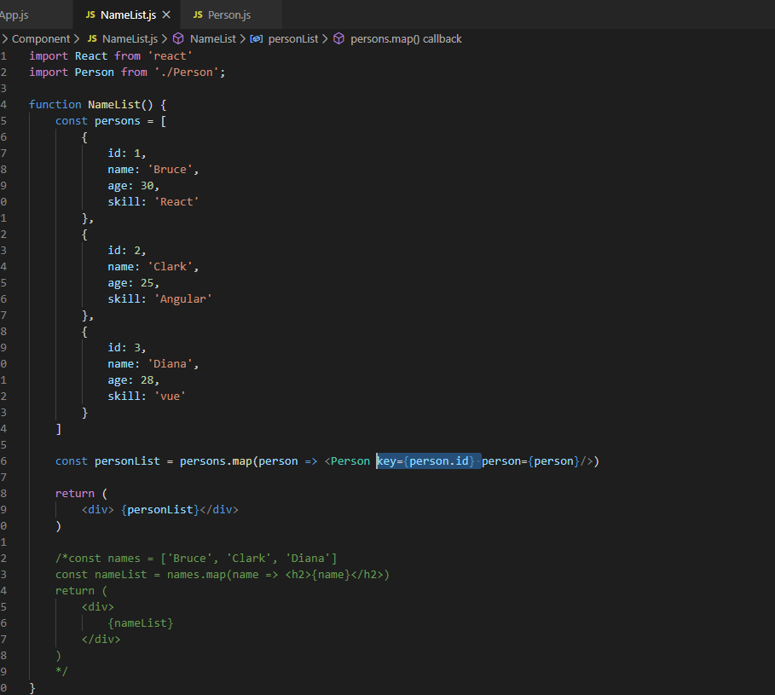

The key prop value need not be id all the time, it could be name also or can be anything as long as we are sure it is unique within the list like name property in this example which is unique.

Key prop is a special attribute which need to include when we create list of elements.

Key prop is not accessible in the child component, it gives warning (‘key’ is not a prop, trying to access will result in ‘Undefined’) in the browser (below screenshot).

Key prop is reserved and used by react to render list efficiently.

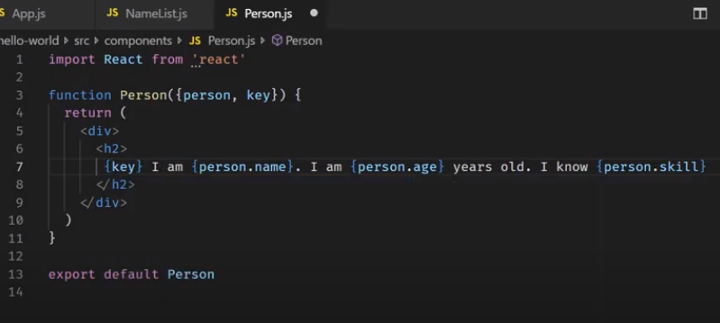

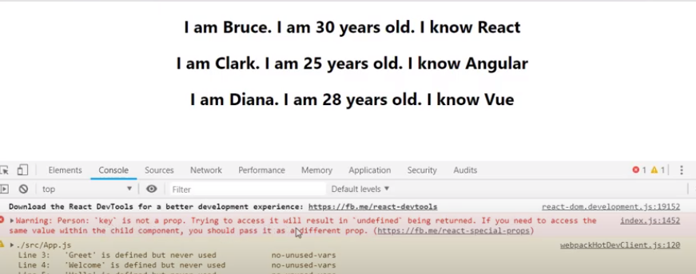

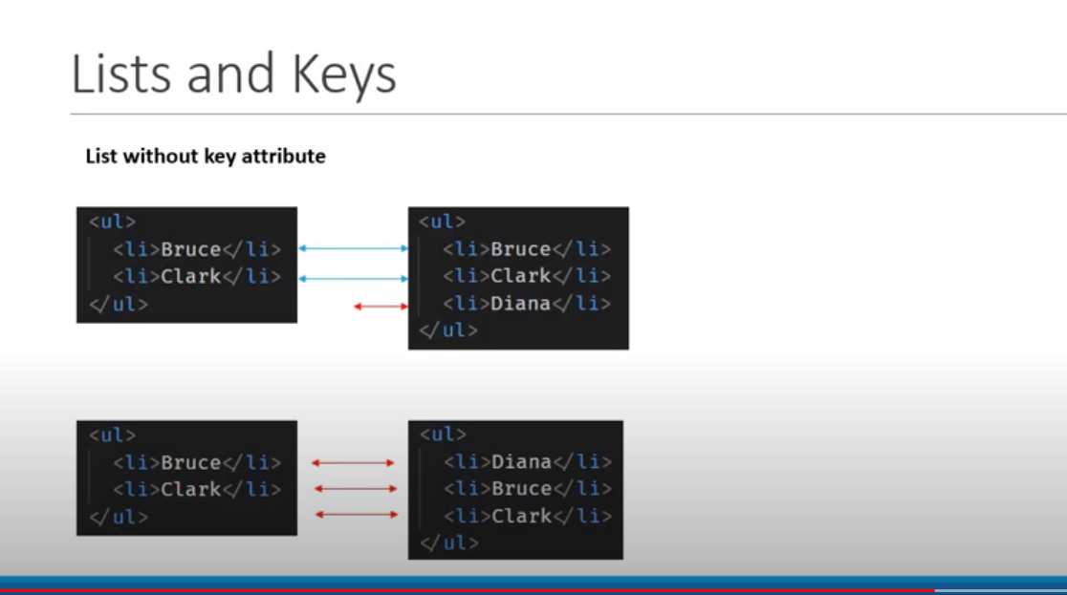

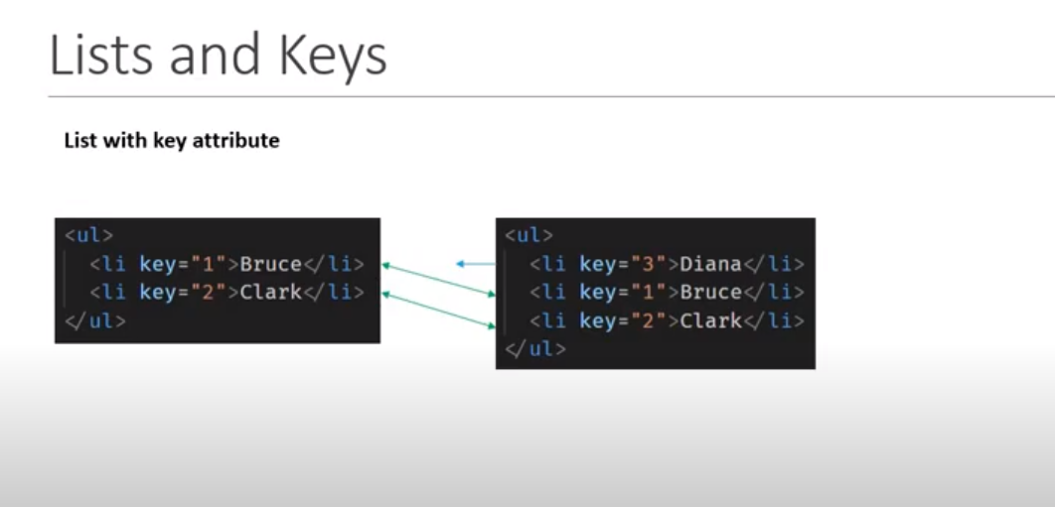

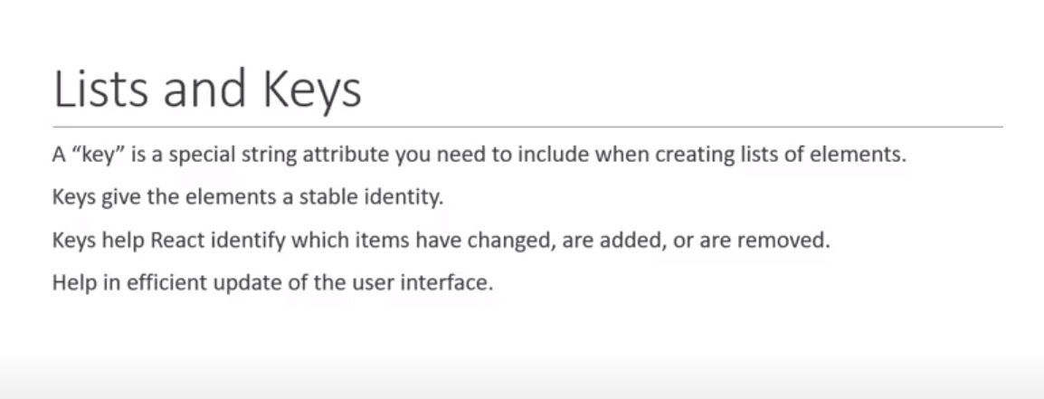

## Index as a key

We can pass index as a next parameter in the arrow function and can use index as a key prop to identify the list uniquely.

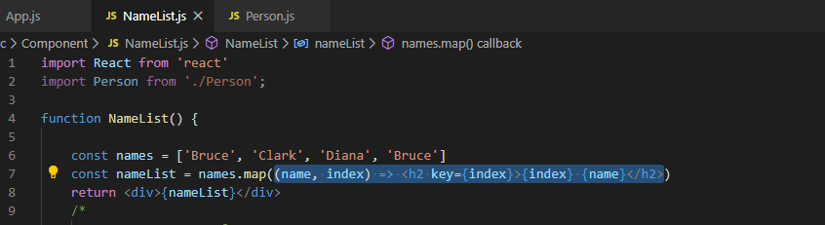

Problem in using Index and when to use it: -

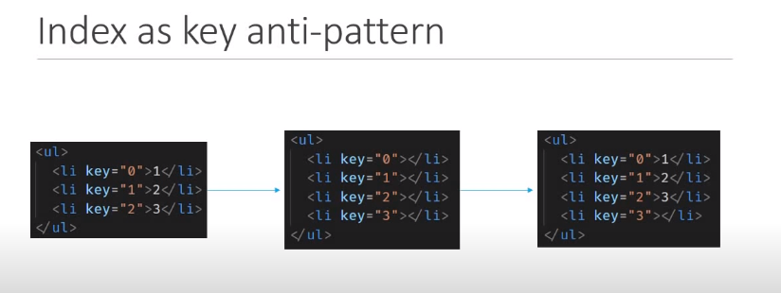

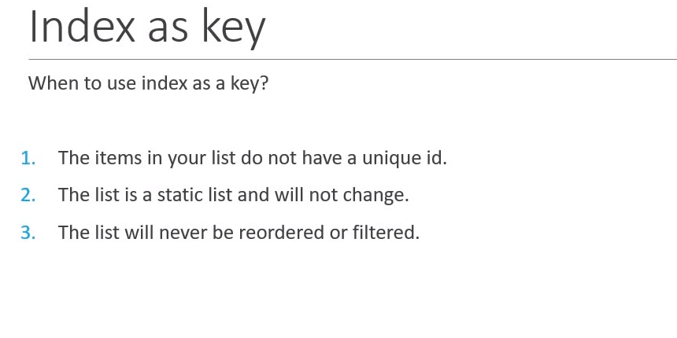

# Styling React Component

1) CSS stylesheets

2) Inline styling

3) CSS Modules

4) CSS in JS Libraries (styled Components)

## CSS stylesheets

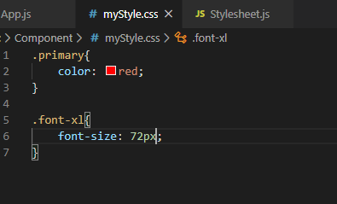

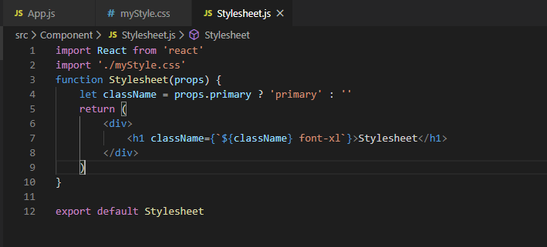

## Inline CSS

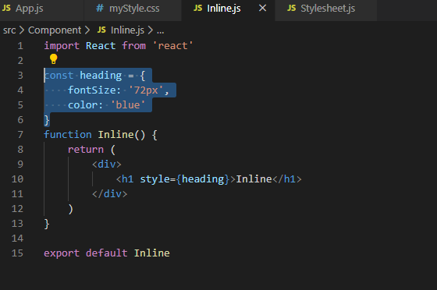

## CSS Modules

Class name should be <ClassName>.module.css

Classes are locally scoped by default since CSS class is imported using variable name like we import non-default class.

Normal CSS applies to child component also i.e., can use the same CSS to child component also, but this does not applicable to module CSS, it’s scoped is locally. Can’t use the module class that is defined or imported in another component.

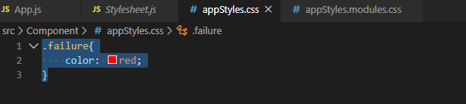

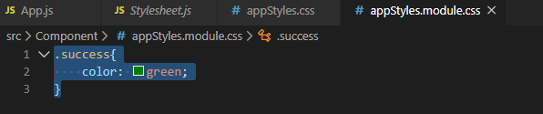

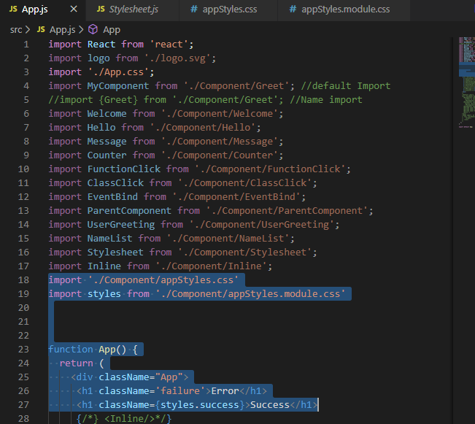

# Basics of Form Handling

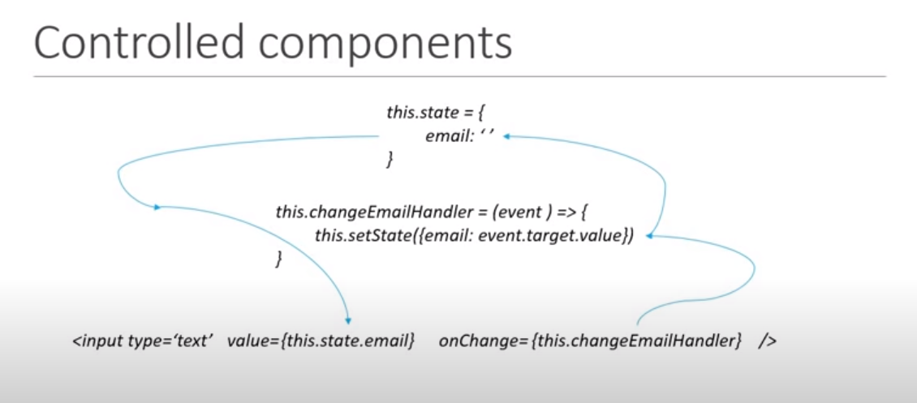

As we assign handler to onChange event, the event itself is passed as a parameter to the event handler and can extract the value of the input element by using **event.target.value,** will be using setState to update the value to the state.

event.preventDefault() is used to stop refreshing the page once we click submit button.

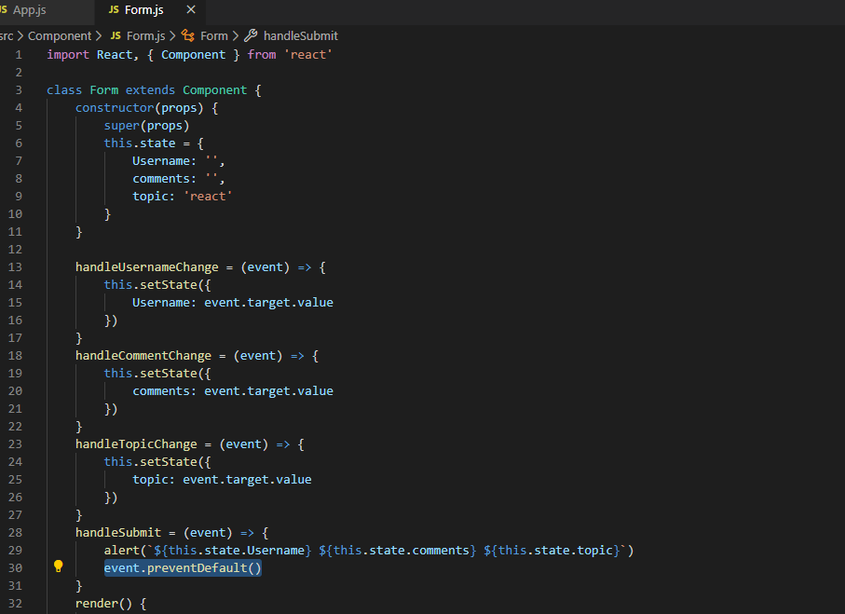

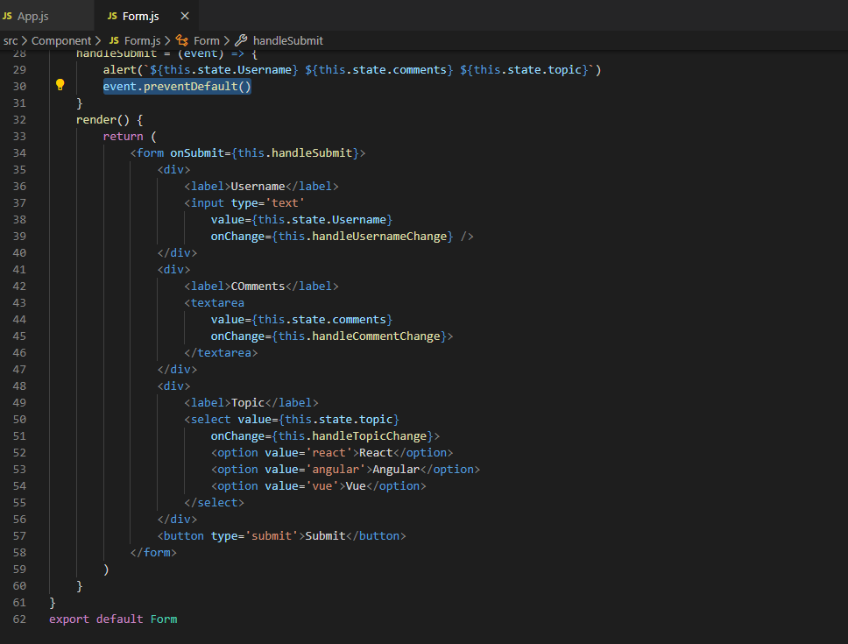

# Component Lifecycle Methods

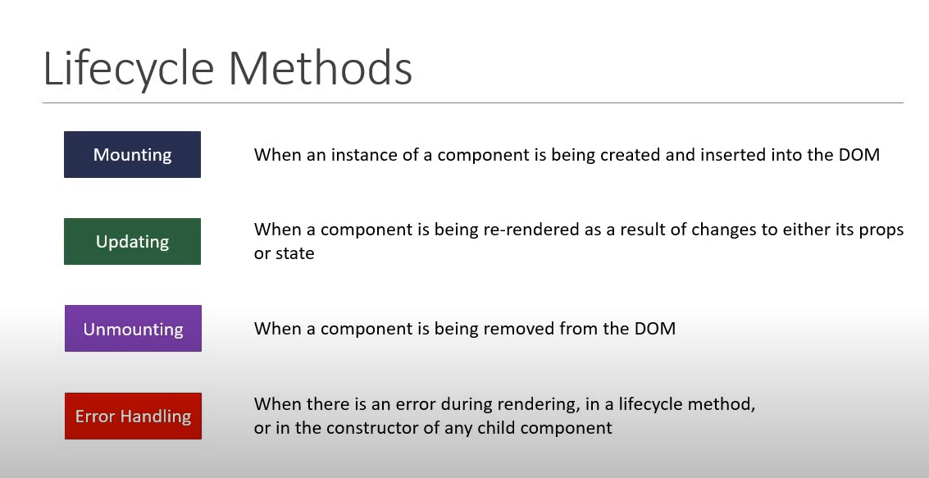

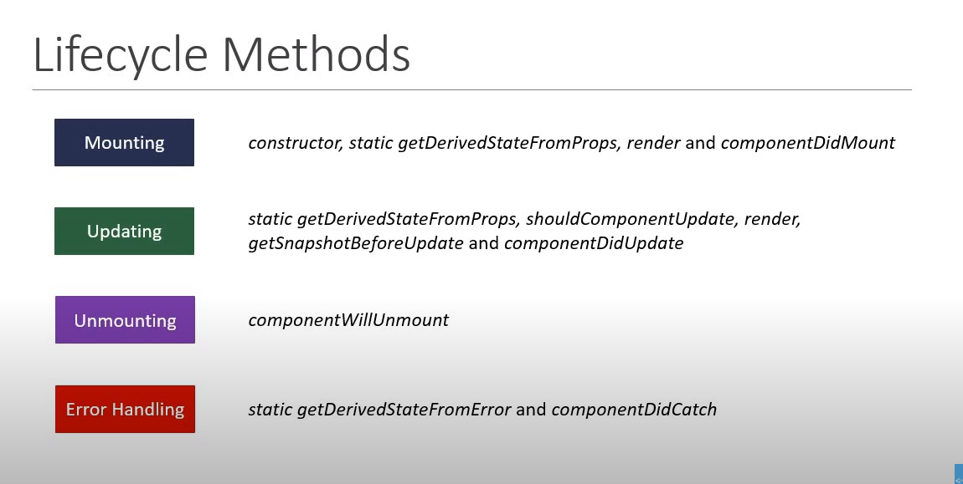

## Component Mounting Lifecycle Methods

Methods which are called when an instance of the component is being created or inserted into the DOM. Method invocations order are: -

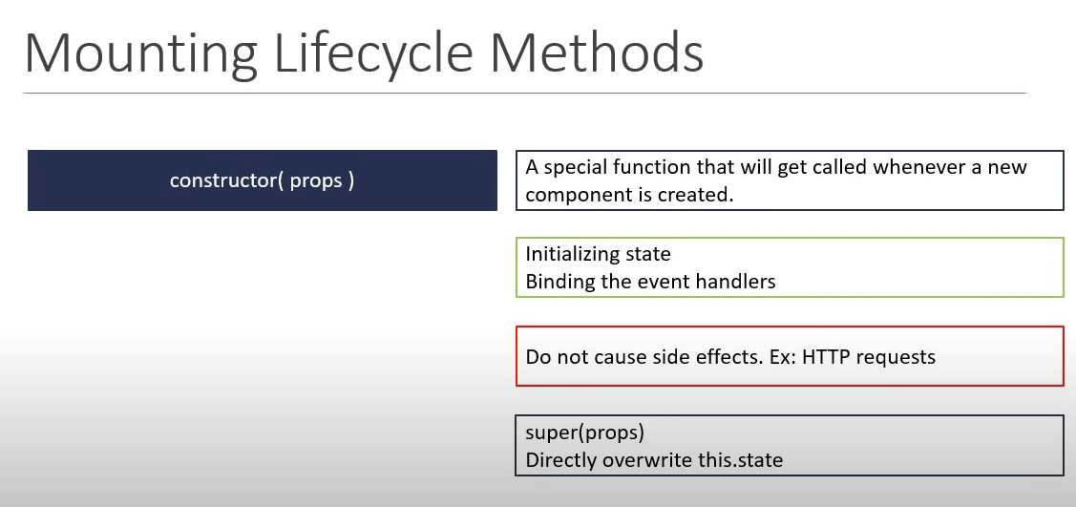

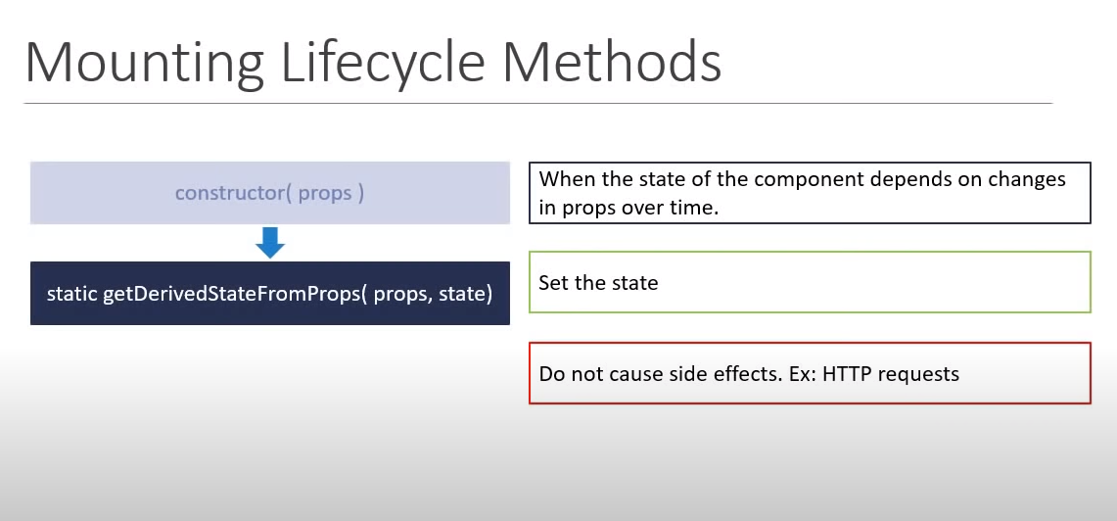

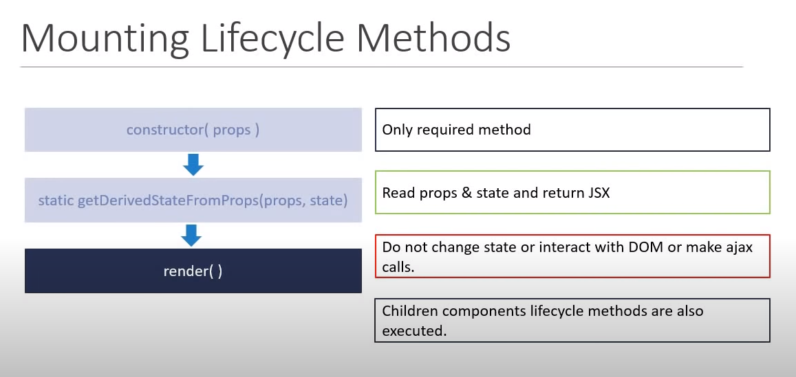

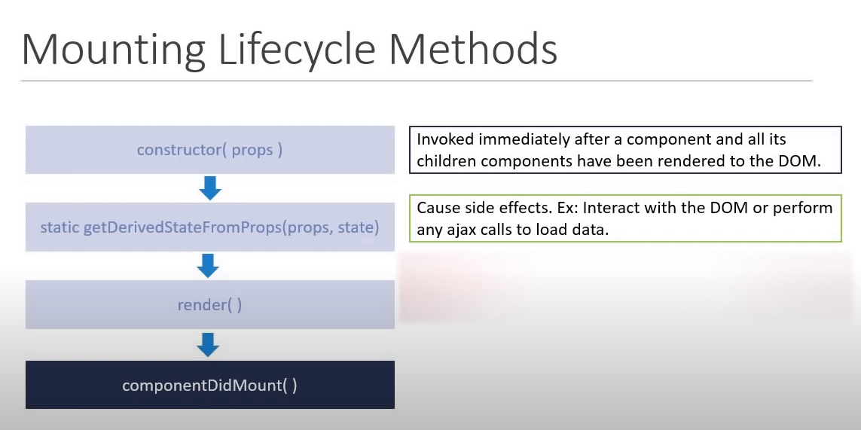

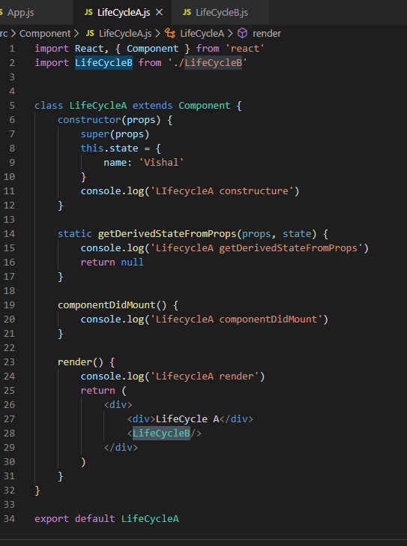

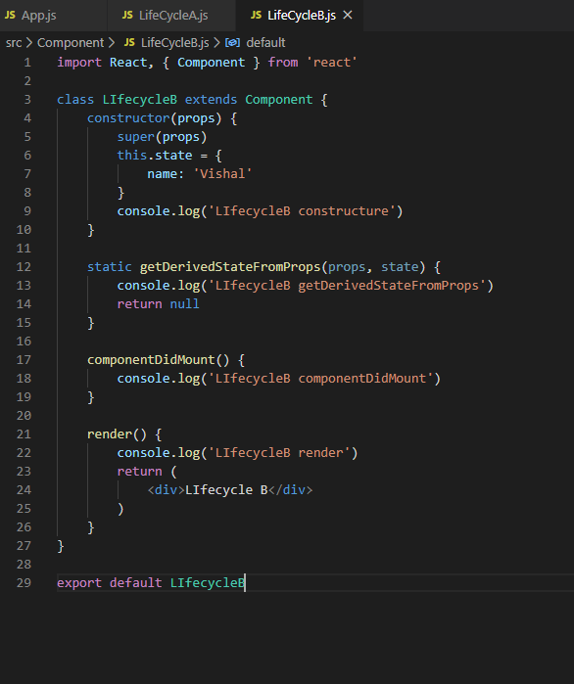

## Updating Lifecycle Methods

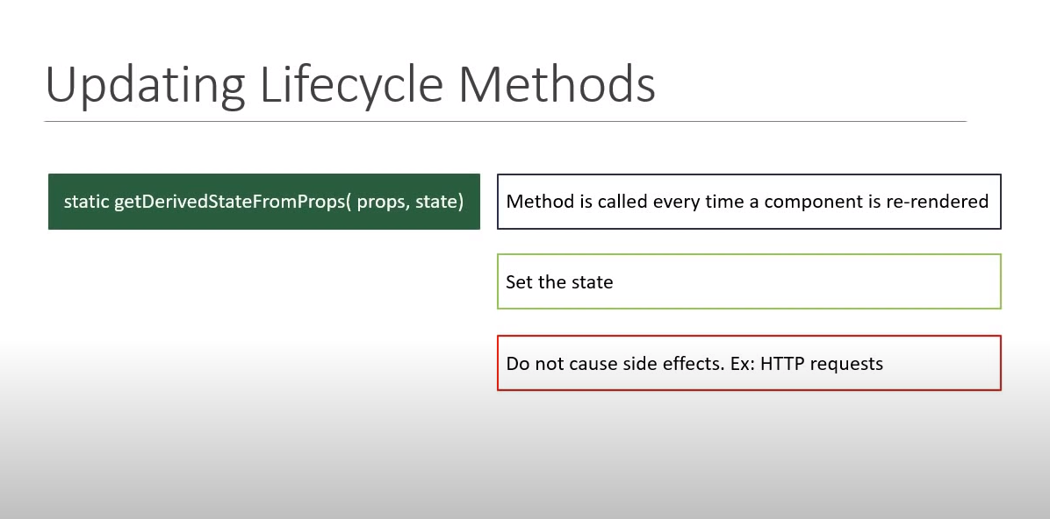

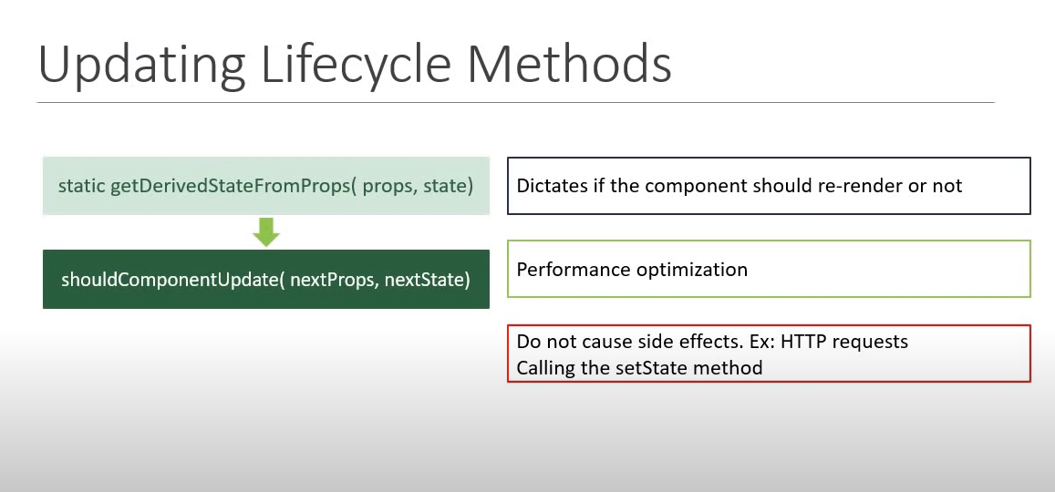

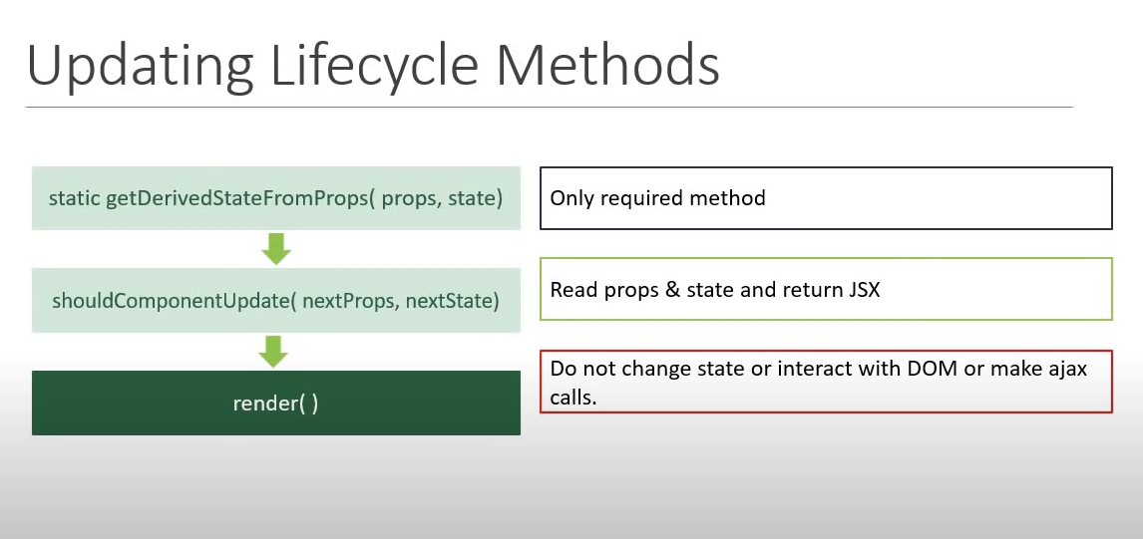

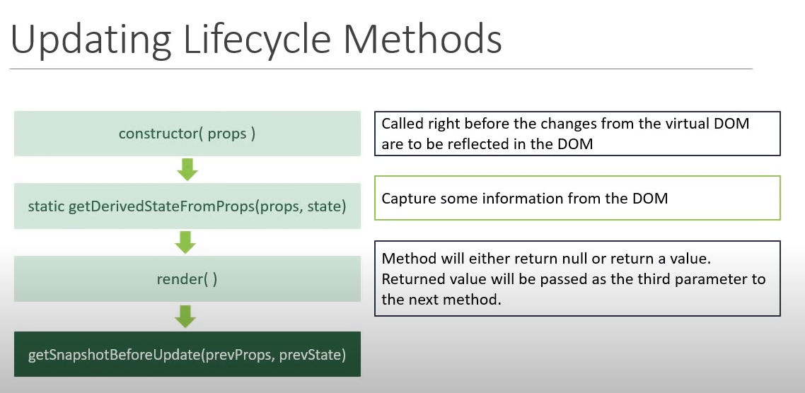

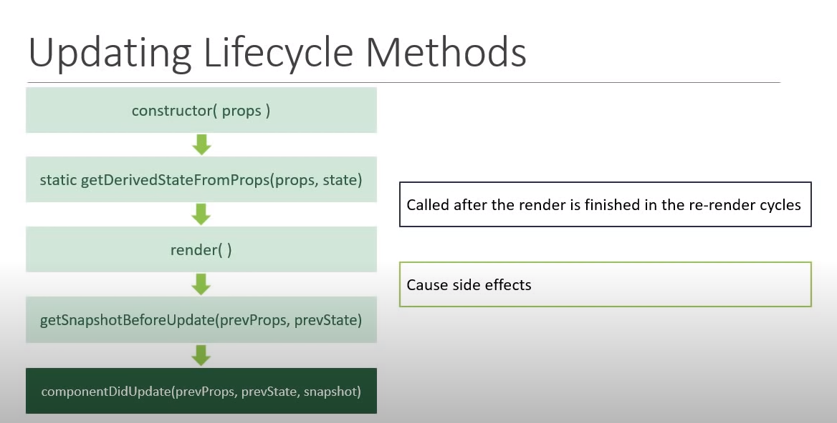

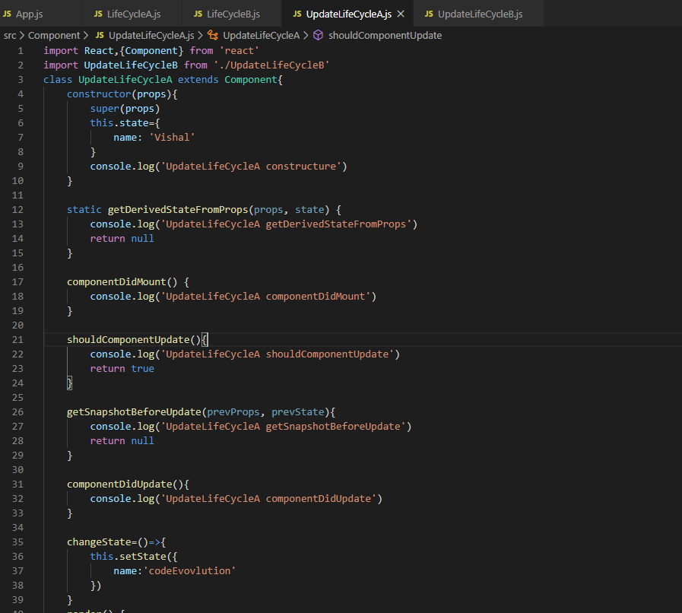

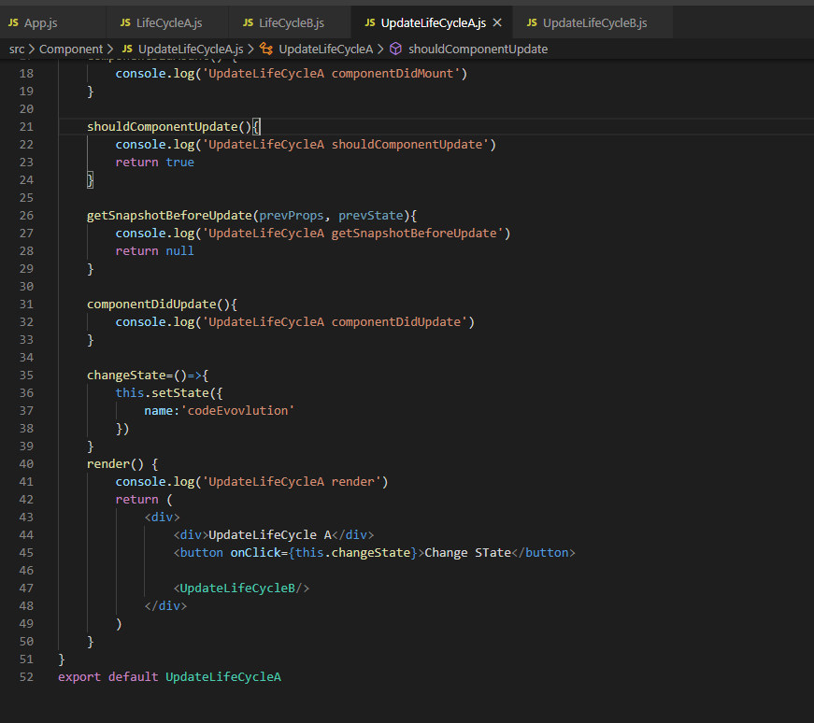

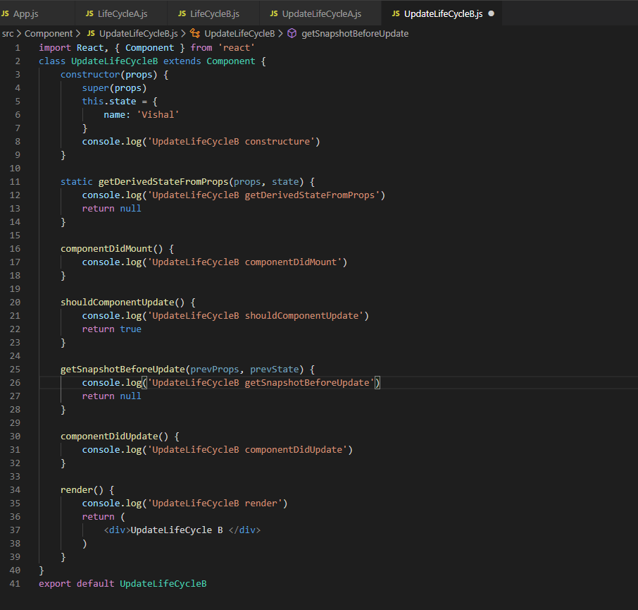

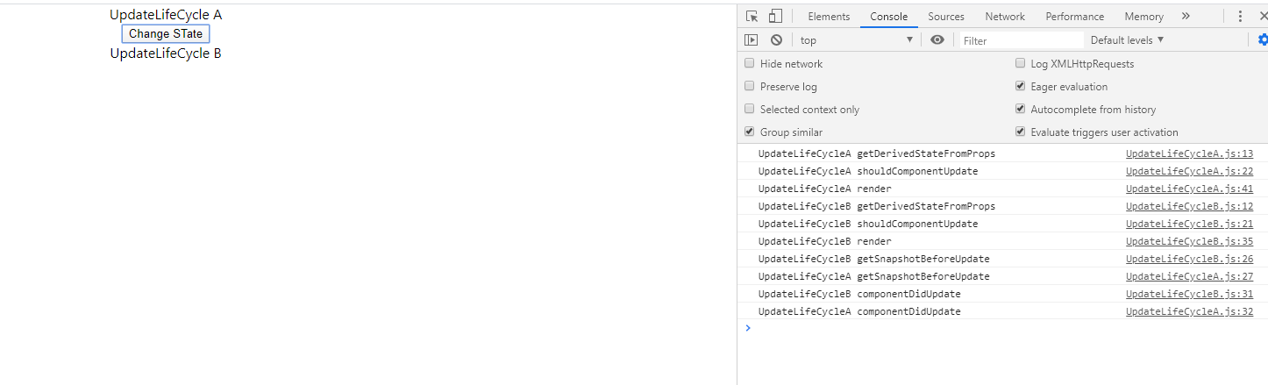

## Unmounting Phase Method

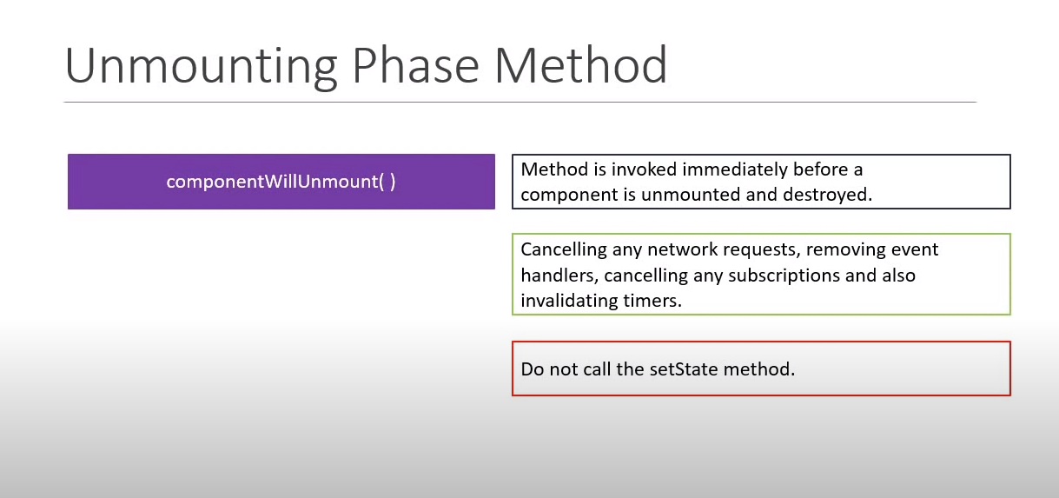

## Error handling phase methods

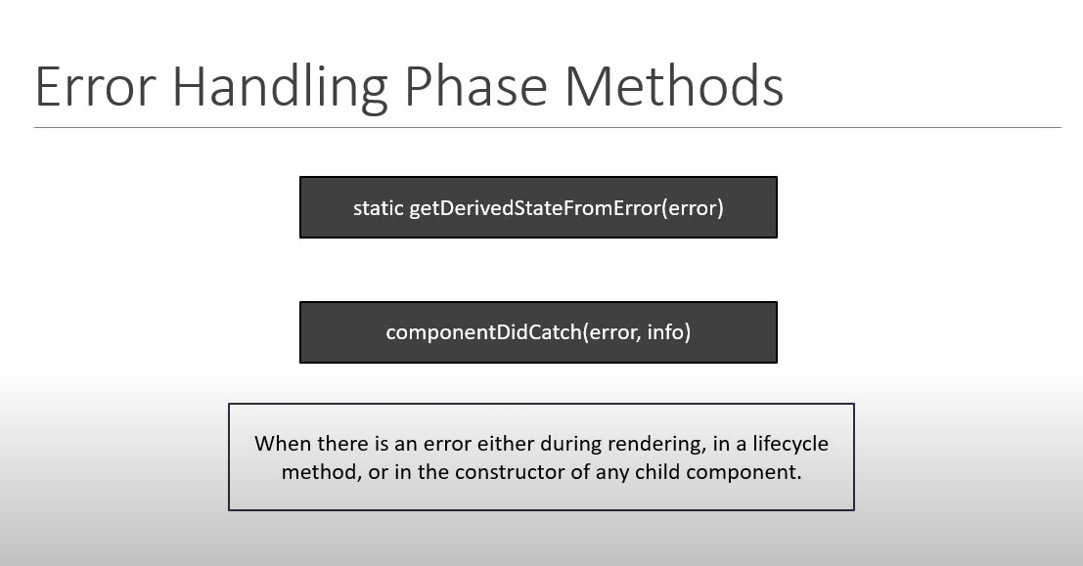

# React Fragments

Fragments let us group a list of children elements without adding extra nodes to the DOM.

Since in react’s return () method we allow to return only one element that’s why we always enclose our all elements into div tag. But it unnecessary creates an additional div tag in the DOM just to enclose all elements. Here reacts **Fragments** comes into picture to get rid of additional div tag in the DOM by replacing an enclosing div tag with **React.Fragment tag** and that will prevent an extra node from being added to the DOM.

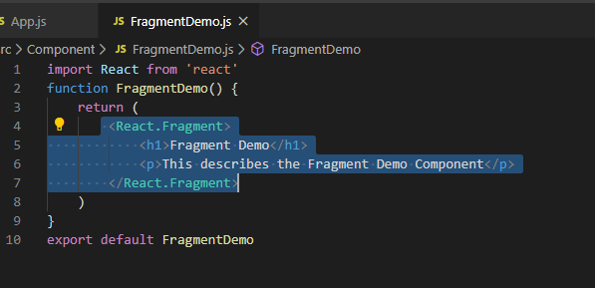

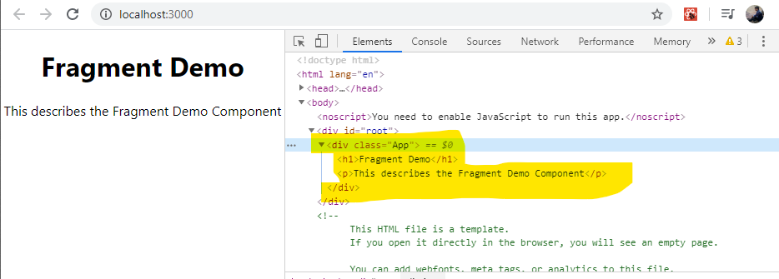

Another use case of Fragment is td should not be appeared as a child of div tag otherwise react give warning (below SS). And div tag is necessary if we have multiple td in tr.

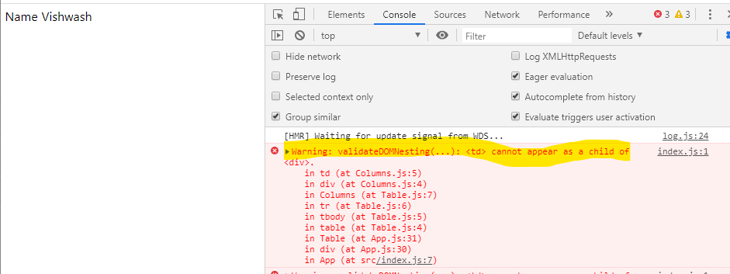

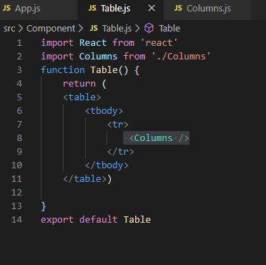

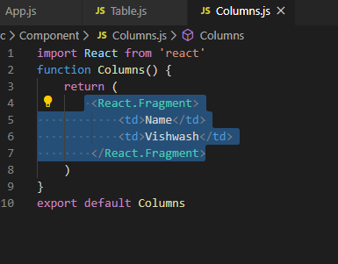

**There won’t be any warning after replacing <div> tag with <React.Fragment> .**

**Fragment can accept the key attribute when rendering list of items** like(not complete example):

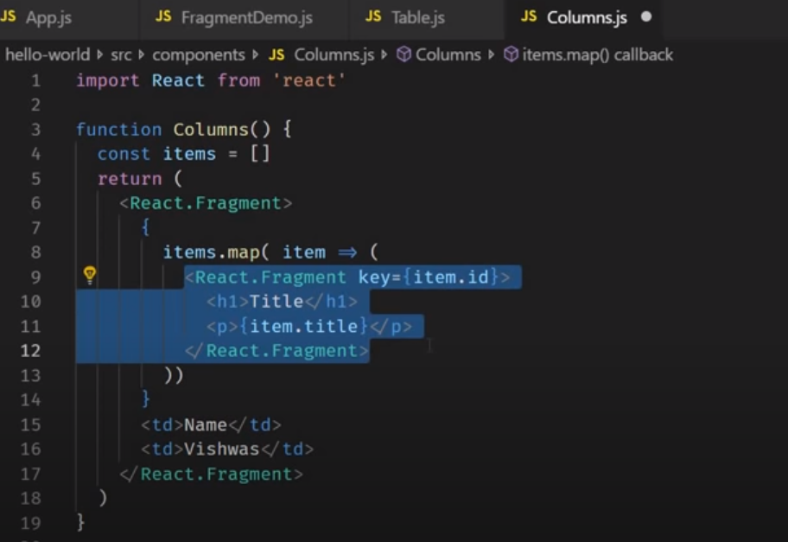

**There is also a shorthand to use Fragment instead of using <React.Fragment> we can use <> </>{only open and close tag} but if we use this shorthand, we can’t pass key attribute.**

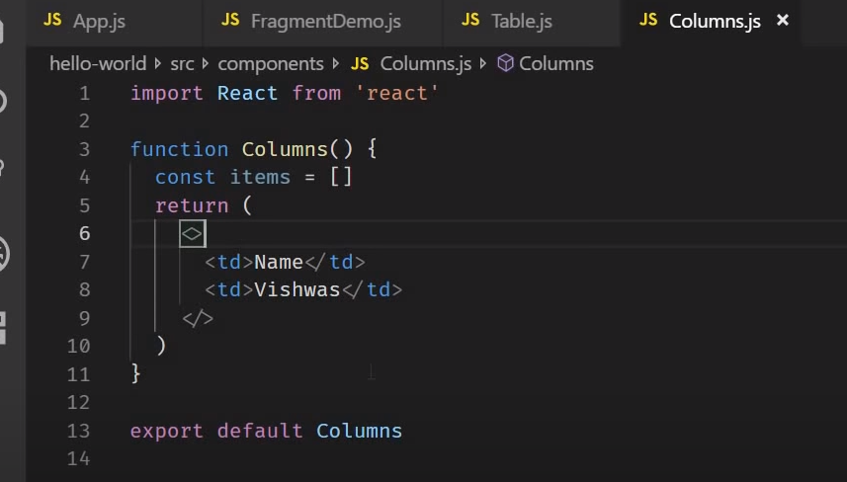

# Pure Components

Till now we have created Component by extending Components class but there is another way to create Component and that is by extending PureComponent.

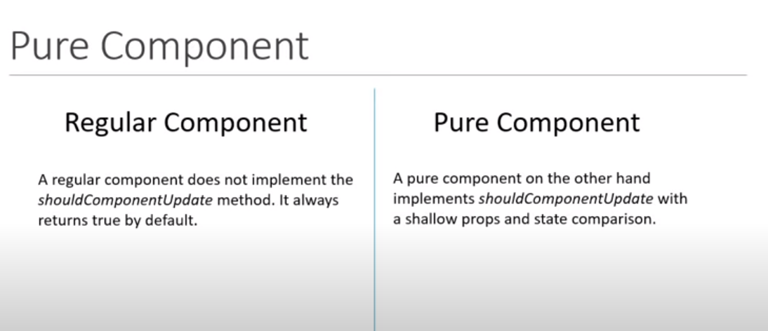

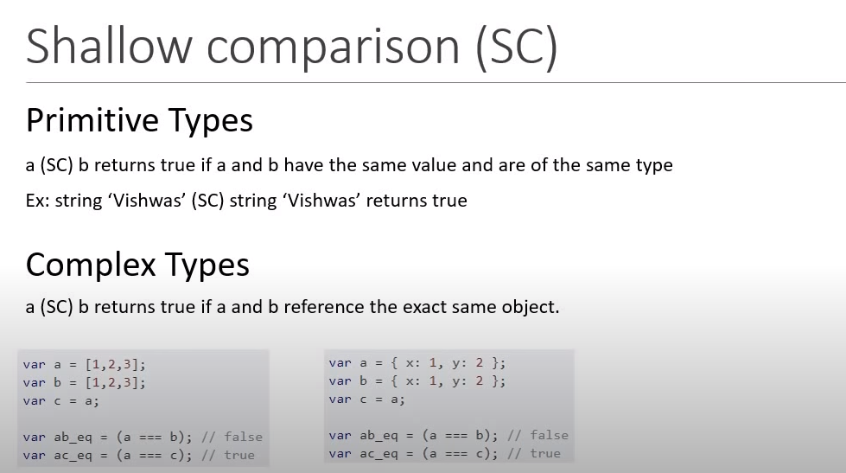

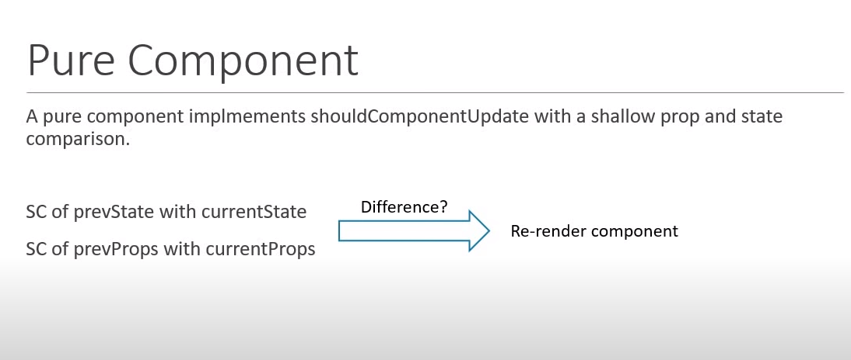

Pure Components by preventing unnecessary renders can give you performance boost in certain scenarios like if we are rendering list of 50 items by not re-rendering them when it is not required then we are going to have good performance boost.

**Should not mutate obj or arrays in props and states** for example if we need to add an item into the list, don’t mutate it by pushing the item into the list , reference to the array never changes and because of pure component only check for that the component will not re-render even if there is a difference. Always return a new object or reference while dealing with Pure Component.

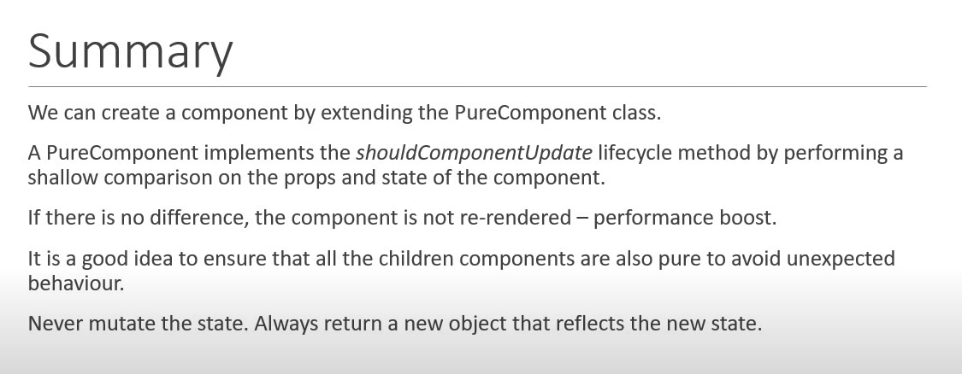

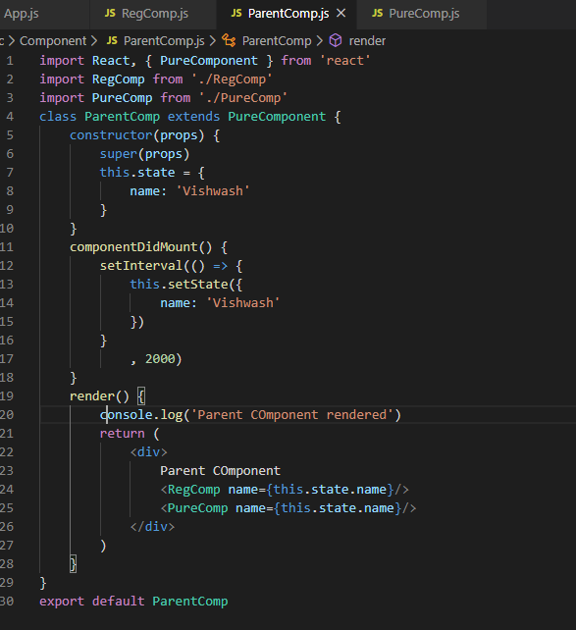

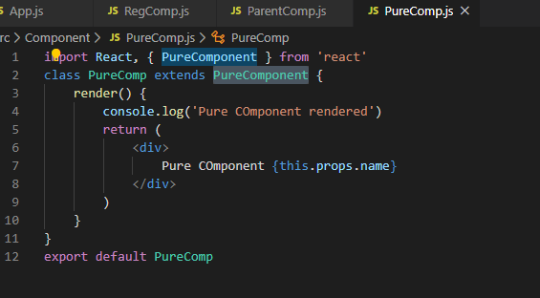

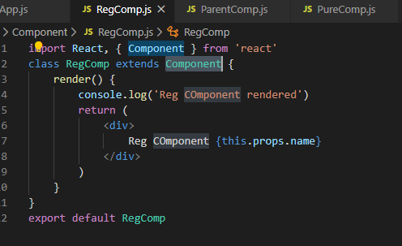

# Memo

Memo is a concept of using Pure Component in Functional Component like class Component. Pure Component is a class-based component whereas Memo is a Functional based component.

It is like Pure Components, but it works with Functional Components.

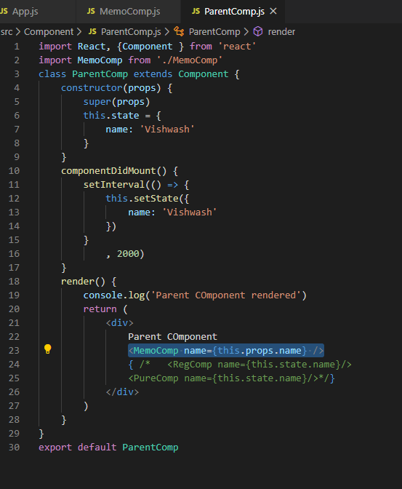

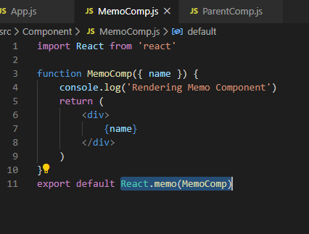

# Refs

Refs in react is used to access DOM nodes directly within react.

3 steps need to follow to implement it: -

1) Create a Ref using React.createRef() method.

2) Attach this ref in the input method, by using reserve keyword ref attribute.

3) Call the focus method on this input element by using current.

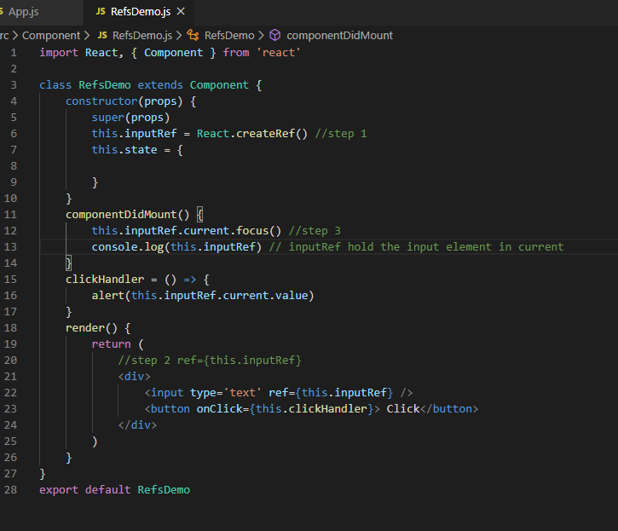

React also supports second way to set refs which is called call Back refs, it’s an older approach to set refs.

It has 4 steps: -

1) Create the ref by creating property and assign the value as null.

2) Create a method that will assign a DOM element to the ref we have just created in step 1.

3) Attach this ref to input element by calling the ref method.

4) Add callback ref and call focus method withing using current in componentDidMount (call back ref is that react will call the ref call back with the DOM element when the component mounts and call it with null when it unmounts that is the reason it is really important to check if the value exists on the reference property and that it is not null)

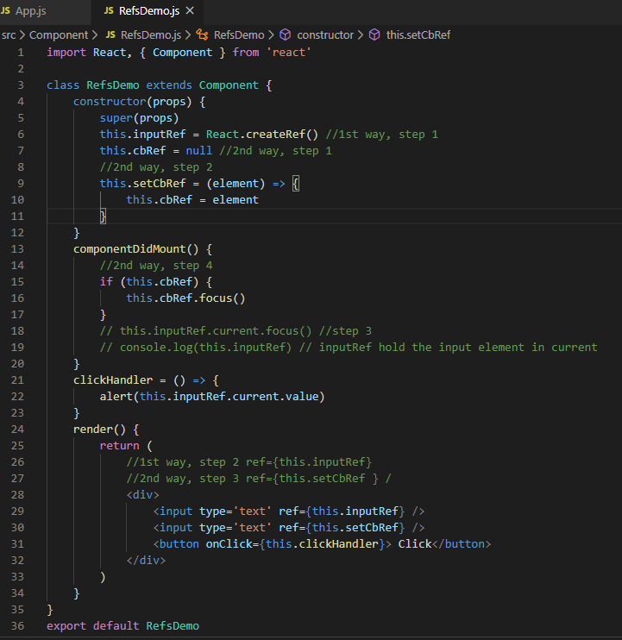

# Refs with Class Component

Till now we have seen to add ref in html component, we can also add ref in class component.

ParentInput component calls the input tag of Input component which is a child of ParentInput.

To do this create a method (focusInput) in child Input component and call that method from the parent onclick event handler and create ref as usual in parent and child component both as learnt above.

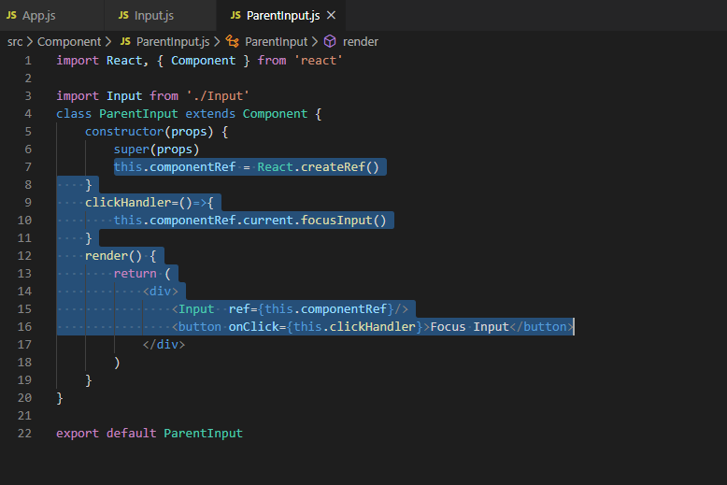

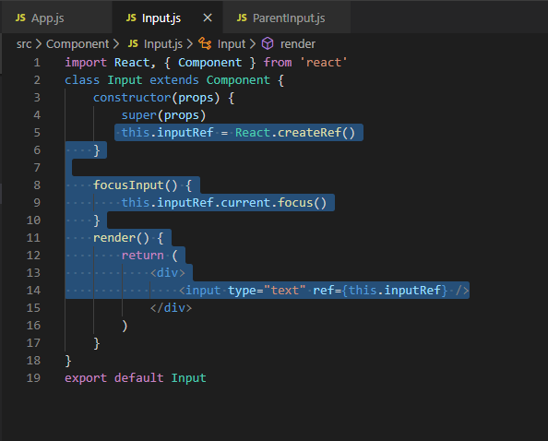

# Forwarding Refs

It is a technique for automatically passing a ref through a component to one of its children.

In last example ref was pointing to the class component, in this example we will use the forwarding ref technique to allow the parent component to directly reference parent native element.

1) Create ref in parent component and attach it to child component instance.

2) need to change the way to define functional component, define functional component by using arrow function. Call forwardRef() method of React class and pass the arrow function. Arrow function takes ref as a parameter other that props which refers to the reference of parent component.

3) Create clickHandler method in parent component to handle the onClick event.

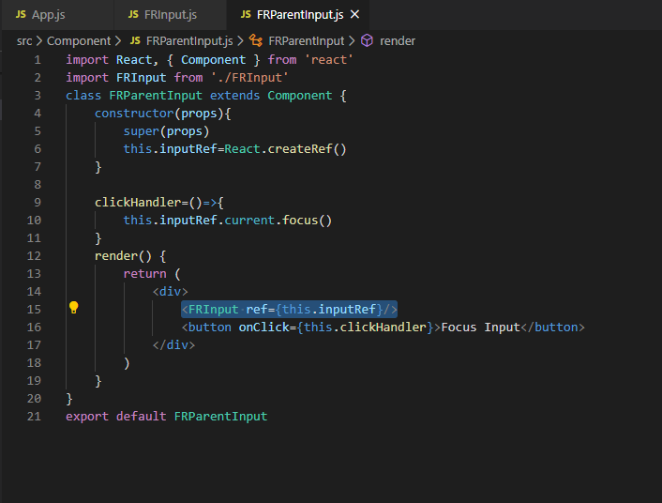

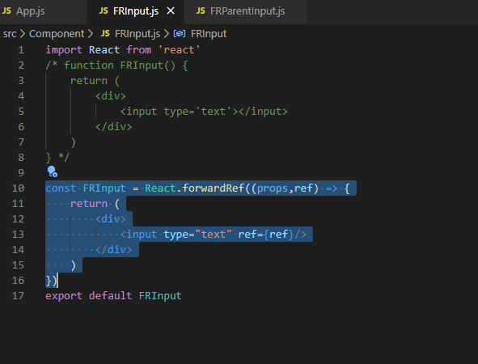

# React portals

React portal provides a way to render children into a DOM node which exists outside the DOM hierarchy of parent component.

So far, we have had one DOM element in html that we were mounting react application into, we can see in index.html and index.js. So, if we see in the browser every single react component in our application fall under the root element.

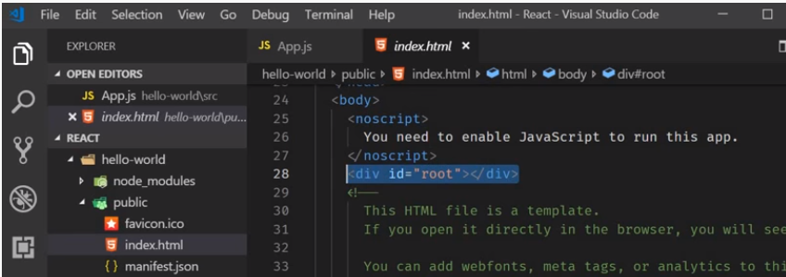

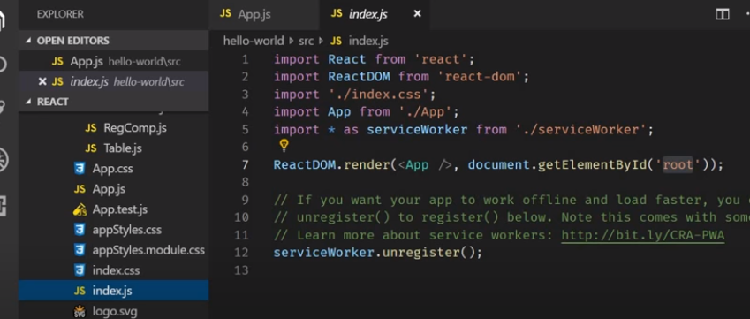

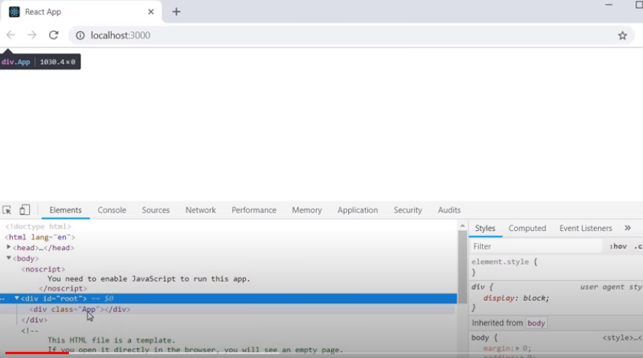

React portals provide the ability to break out the DOM tree. We can render the component onto the DOM node that is not under this root element.

First step is to add a DOM node falls outside the root element.

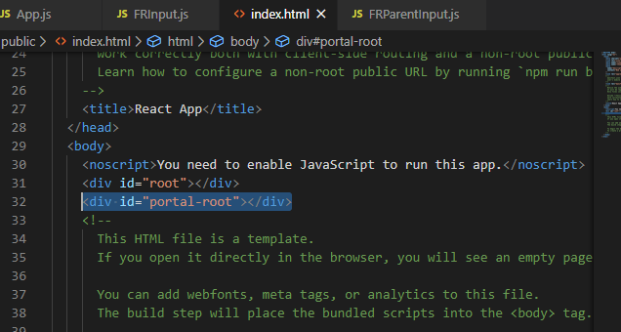

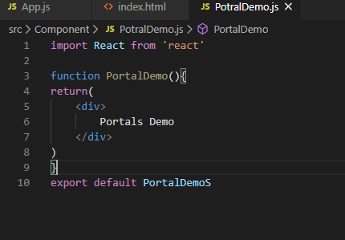

PortalDemo functional component we have created above falls under root element DOM not under portal-root element.

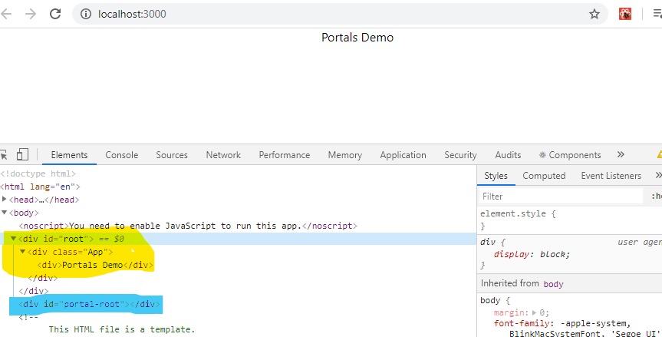

To insert our component under root-portal element will use ReactDOM.createPortal() method and this method takes two parameter which takes two parameter-

1) JSX which we want to render

2) DOM node to mount the element onto.

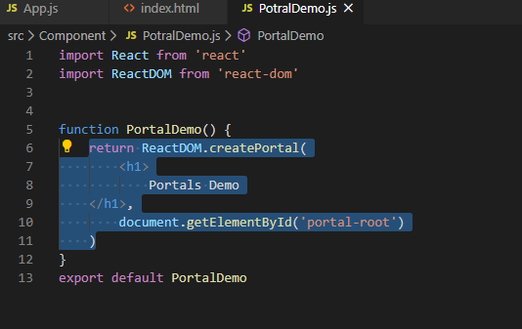

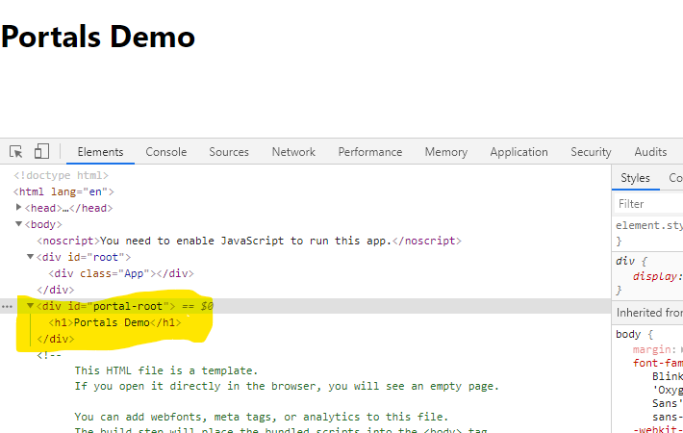

One of the usecase of ReactPortal is having to deal with parent component CSS when the child component is a model, a popup or a tool-tip.

Event Bubbling: - Portal behaves like a normal react child event even if it can be anywhere in the DOM tree. Event fired from inside a portal will propagate to ancestors in the containing react tree even if those elements are not ancestors in DOM tree.

# Error Handing Phase Methods

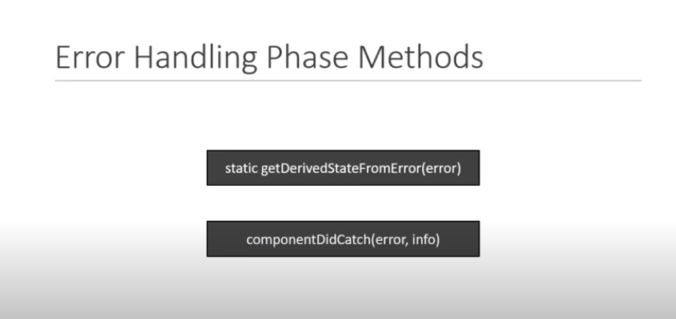

Till now we have seen so far runtime error during rendering broke our application, react basically un-mounds the whole reacts component tree if error occurs.

We can catch the error that comes anywhere in the component tree and display the fall back UI. This is where the error boundary comes into the spotlight.

To define a class component as an error boundary we need to define either getDerivedStateFromError() or componentDidCatch() method in the component.

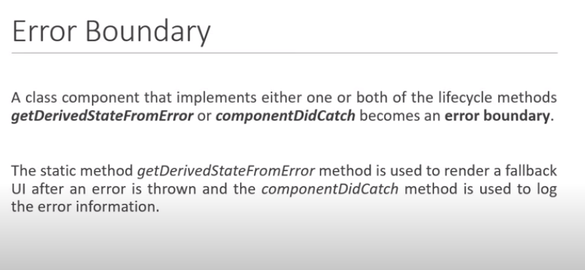

Wrap our app component with ErrorBoundary component.

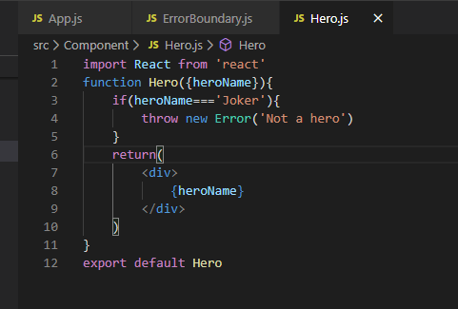

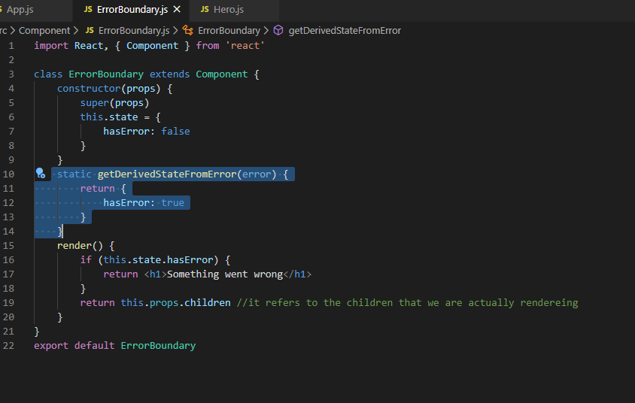

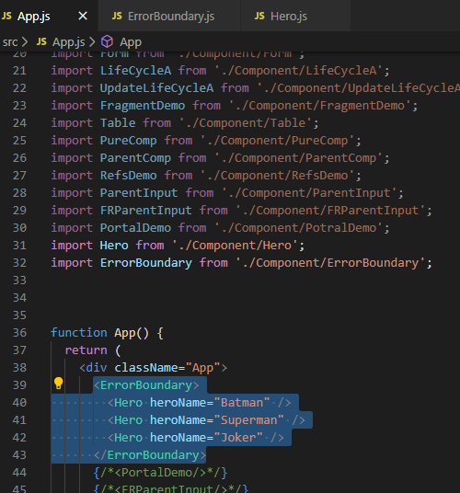

Now we have wrapped all our Hero component in app.js in a single ErrorBoundary component that is not an ideal condition. Let us assume we have online shopping page and there is an error in one product. So, because of single product we cannot stop rendering entire component. So, the best way to wrap an individual component with ErrorBoundary, so that only single component throws error and show fall back UI and other shows the exacts component.

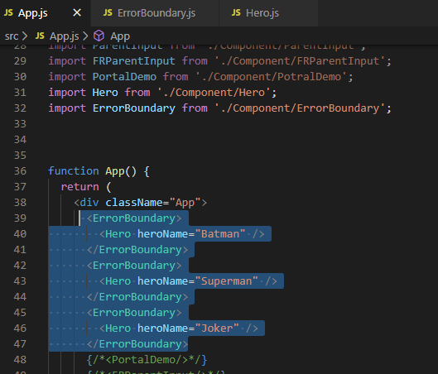

2nd method to catch error is componentDidCatch, used to log the errors on console, takes two parameter error and info. This method mostly uses in production env because in development env logs are already gets captured.

ErrorBoundaries catch error during rendering in lifecycle methods and in the constructors of the whole tree below them, however it doesn’t catch errors inside event handlers, if we have an onClick handler and want to catch an error then we just need to use the regular try catch statements not errorBoundary.

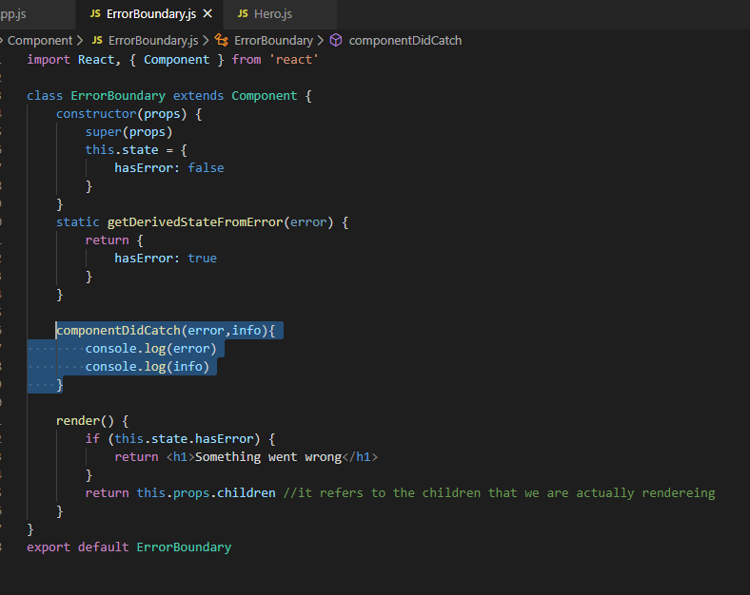

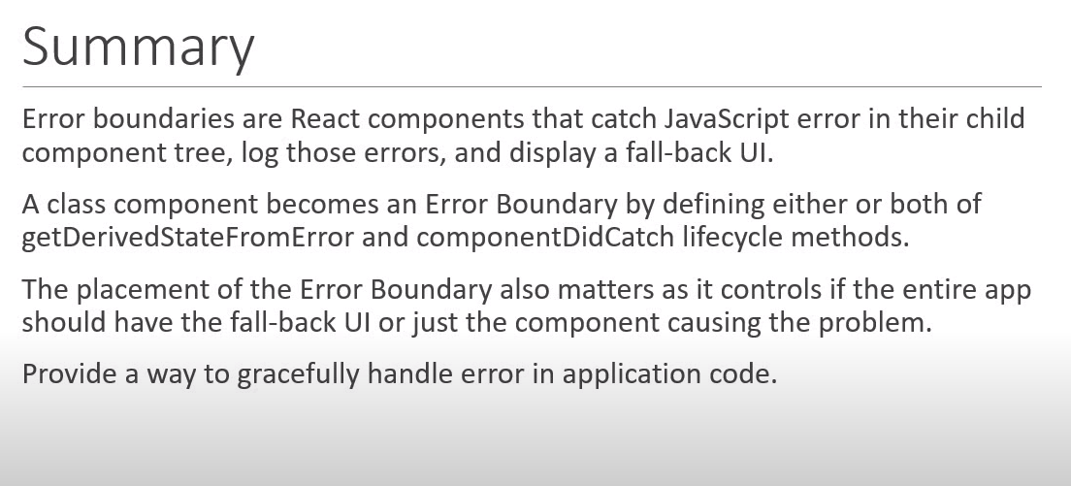

# Higher Order Components

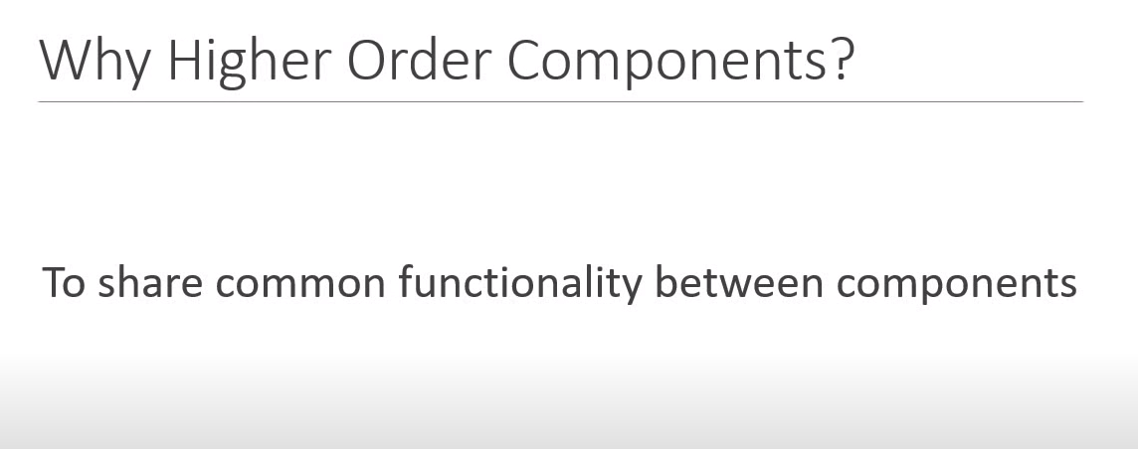

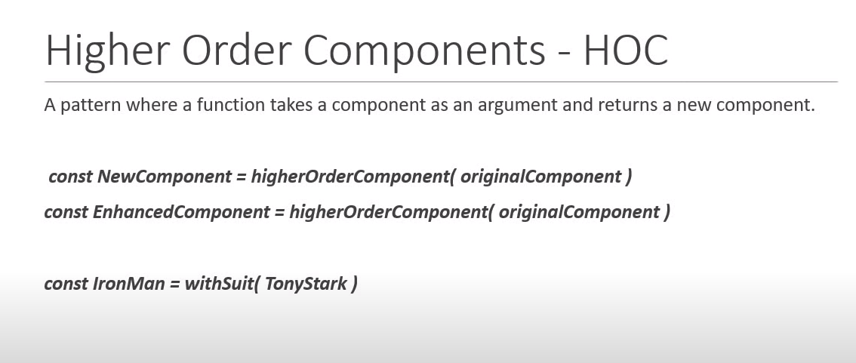

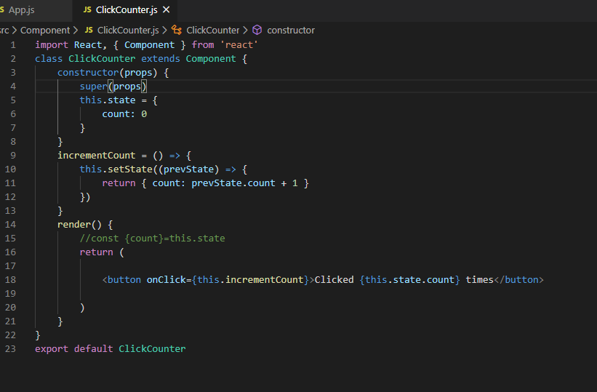

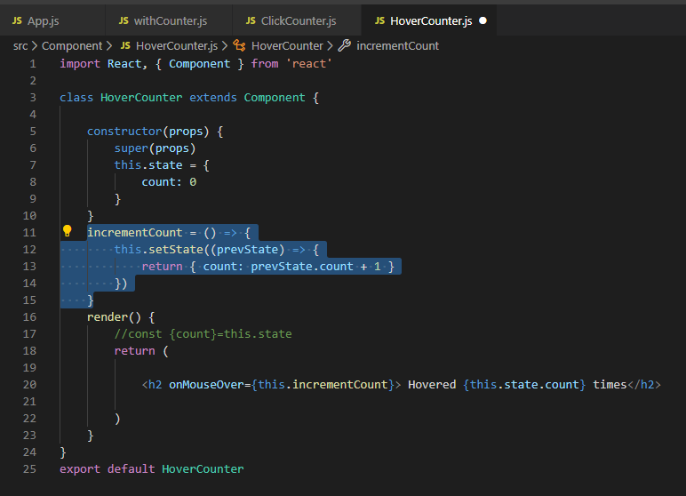

Since both ClickCounter and HoverCounter does the same thing i.e., to increment the previous value. And both components have same set of method to implement this.  
The idea is to have a new component which takes the HoverCounter and ClickCounter. And add this increment logic and return it. So will move this common piece of code in new component that will be our higher order component.  
but first will need to know how to create higher order component. HOC will not be a normal component because it takes a component as an argument. So, we will make define component as arrow function.

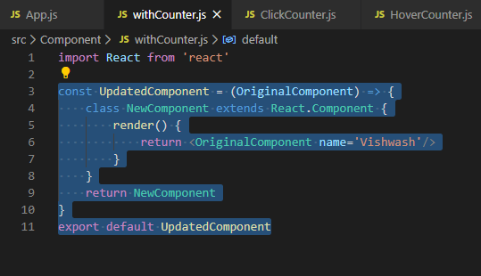

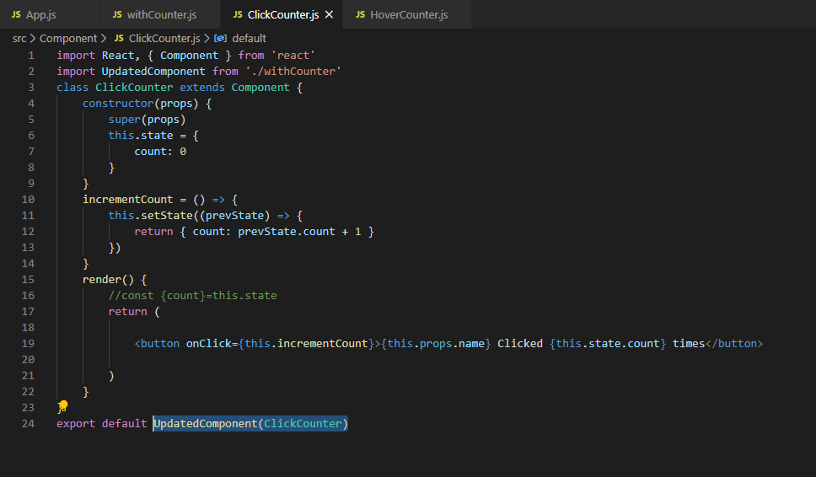

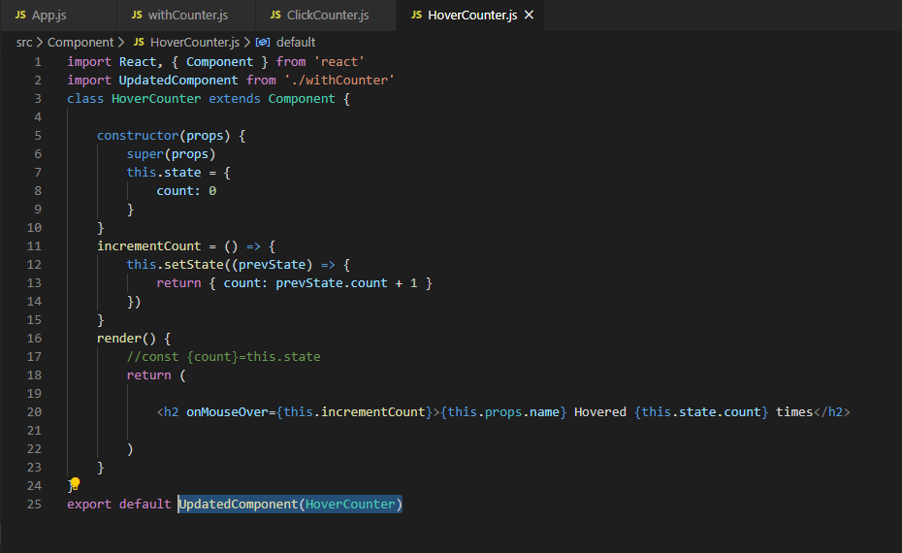

In above example we can see UpdateComponent takes HoverCounter/ClickCounter and add name ‘Vishwash’ and return it.

So, HOC inject name prop to the component required.

Similarly, we will implement counter functionality.

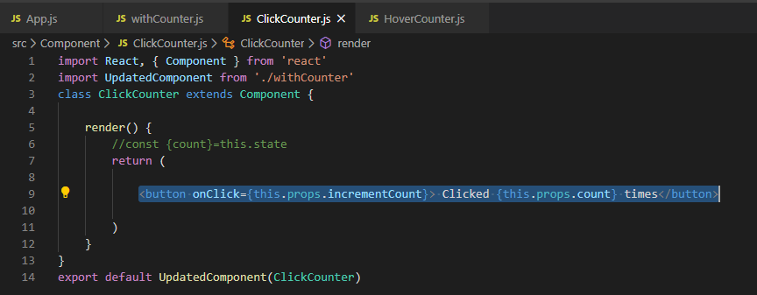

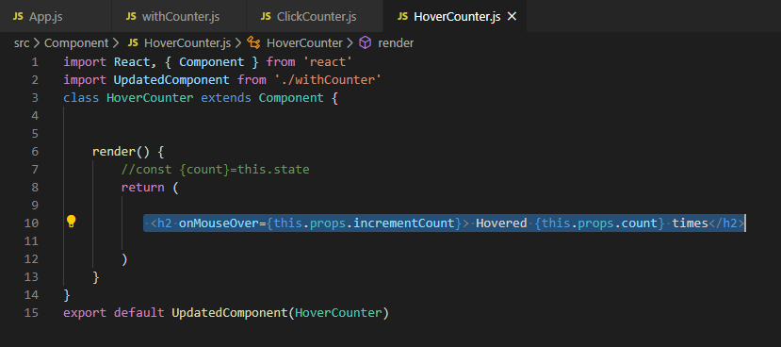

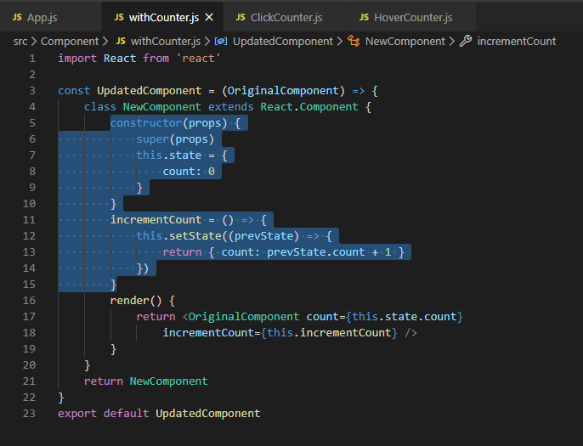

Naming convention: - typically component name and file name should be same. It indicates the functionality that will be added to the component.

Original components generally referred as WrappedComponent i.e., component wrapped with HOC.

New Component name should be same as function name but with pascal or camel case.

Below SS with naming convetion.

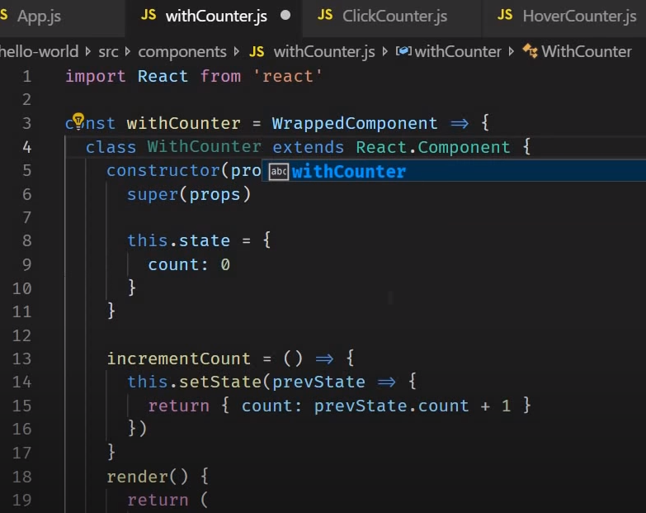

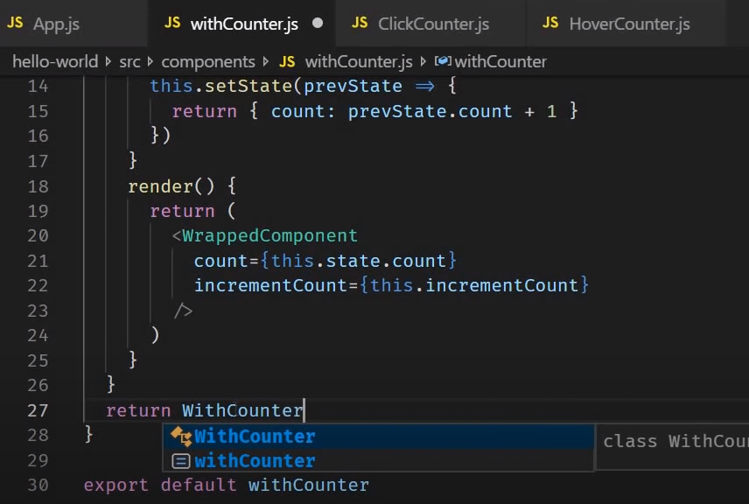

**Note: -** If we pass property from app.js, then that will not be received by ClickCounter and HoverCounter.

Props are sent down to HOC not to ClickCounter. In HOC we can verify this in console.log inside render method. And to pass down these props to ClickCounter or HoverCounter we need to use spread operator.

HOC adds props to wrappedComponent and simply passes down whatever the remaining component have been specified.

Its recommended to pass down all the property when working with HOC.

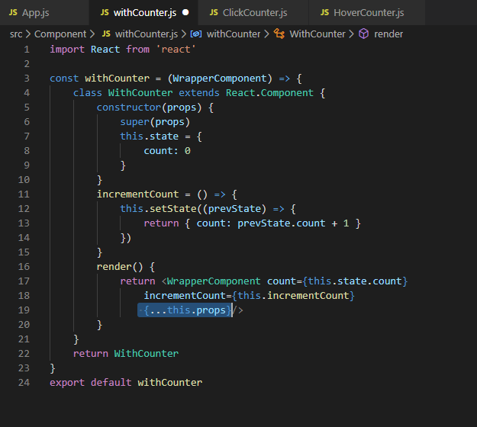

Another imp points to be noted is we can pass more than one parameter in HOC like a use case is user want to increment the counter by 5 in ClickCounter and 10 in HoverCounter, so ClickCounter and HoverCounter need to pass these as an argument and HOC arrow function will takes two parament WrapperComponent and incrementValue like below SS.

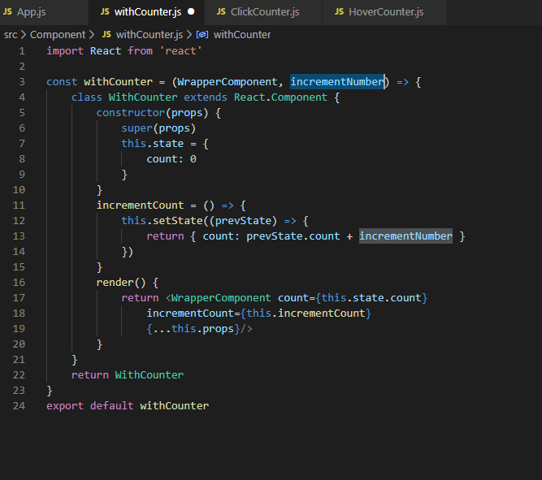

Update ClickCounter and HoverCounter.

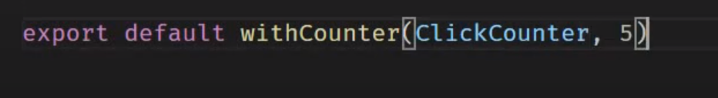

# Render Props

Another way to share codes between react component like HOC.

In react it is possible to use props whose value is the function to control what is actually rendered by the component.

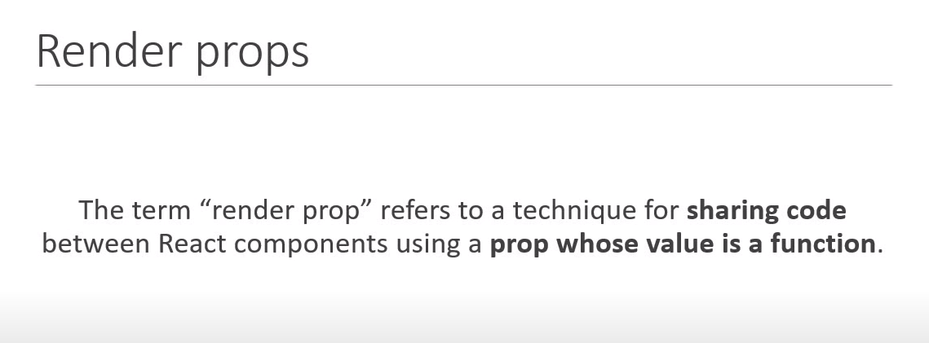

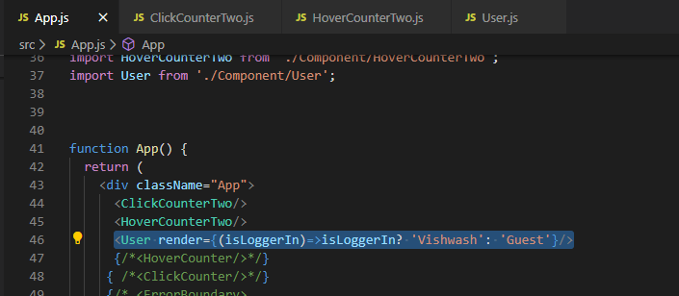

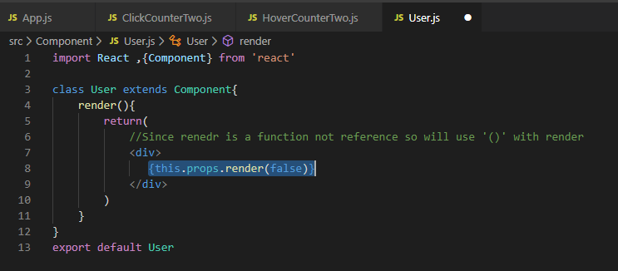

In app component we come across Counter Component.

In Counter Component we have count state and incrementCount method. The counter Component however does not render anything on its own. It is simply going to render whatever passed in render props. And while doing so it passes count sate and increment count method.

Render props is a ClickCounterTwo component and count and incrementCount method is passed to ClickCounterTwo component as props.

ClickCounterTwo Components takes the passed in props and makes use to show in the UI.

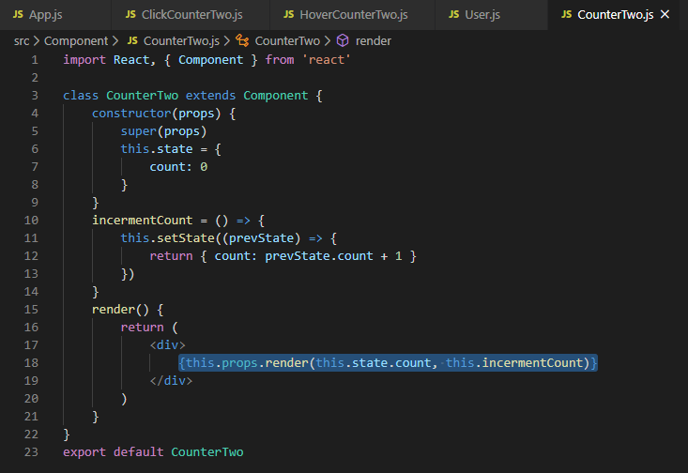

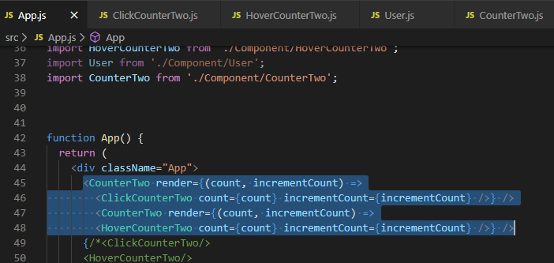

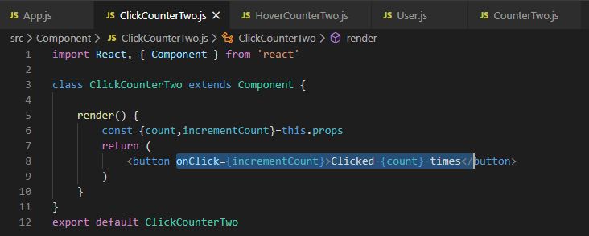

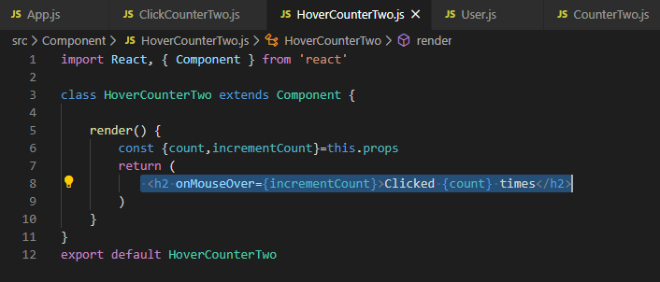

**Note: -** Prop need not be called as render always, it could be anything that we wish to, but it is recommendation to name prop as render.

There is a variation of render props pattern which does not even make use of props instead a children prop is used.

To do this we need to make few changes like instead of render prop we pass in the function in between component opening and closing tag.

And in Counter Component we will change this.props.render to this.props.children. Anything within Components opening and closing tag will passed as children props which is then accessed to render to UI.

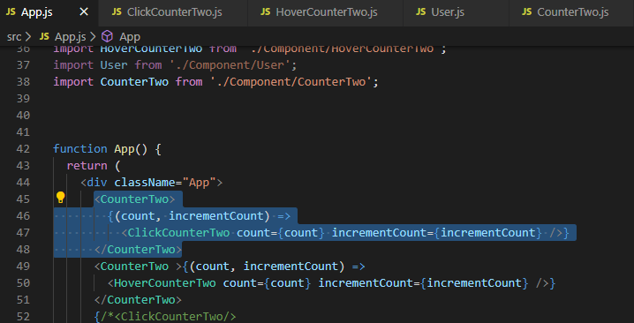

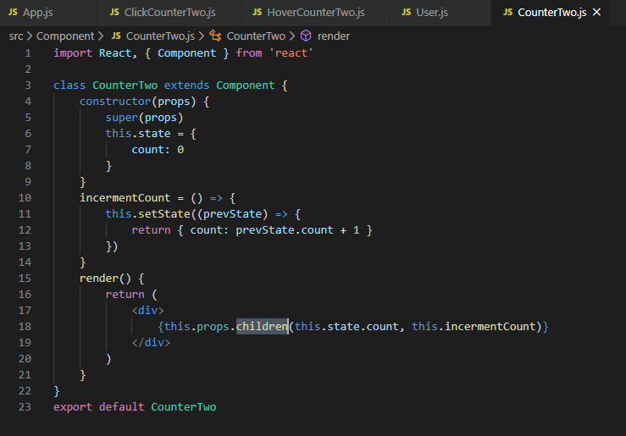

# React Context

We have a use case to print username in component A, D, F, and that username is available in AppComponent.

To print this is A, D and F, we have to pass username as a props to B, C and E component which is not going to use username prop but since to make username available in A, D, F middle component need to carry it. This is where context comes into picture.

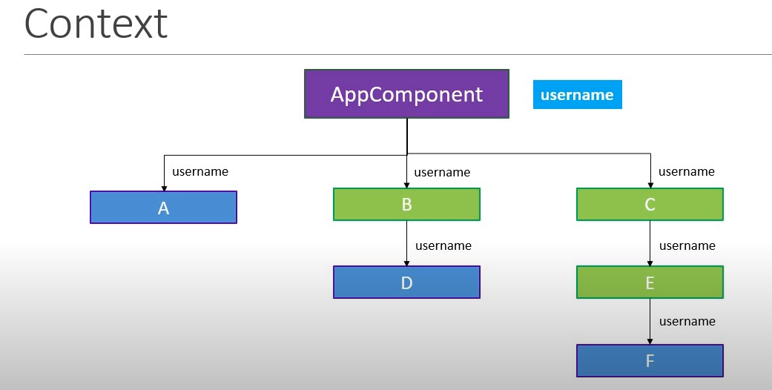

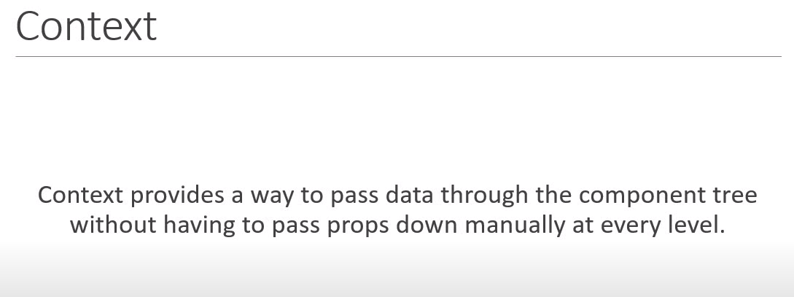

Now we will implement user context which will enable a component at any level to read a prop that is passed at the top level.

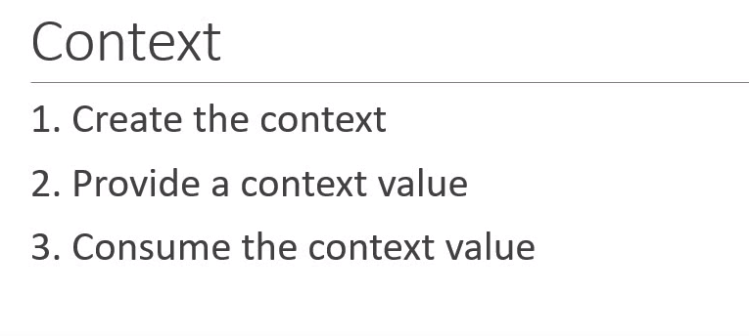

Step 1- Create the context.

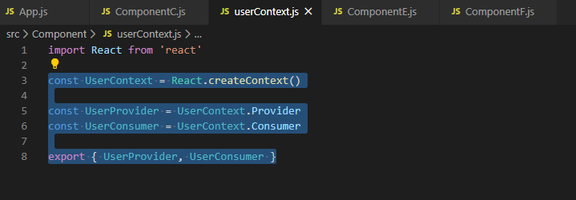

Step 2- provide a context value.

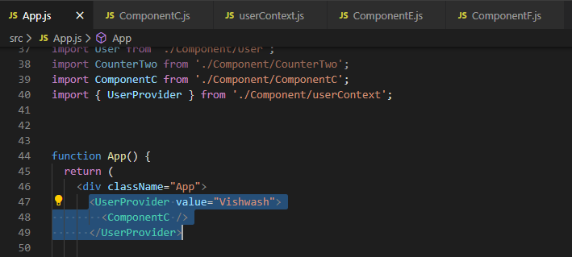

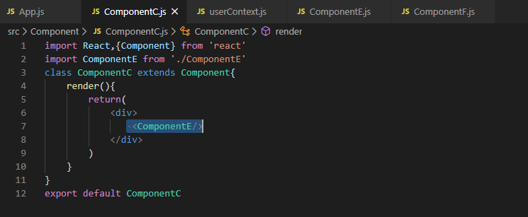

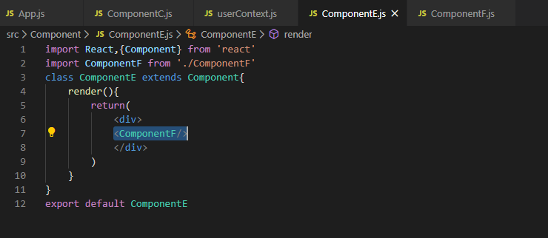

Step 3- Consume the context value.

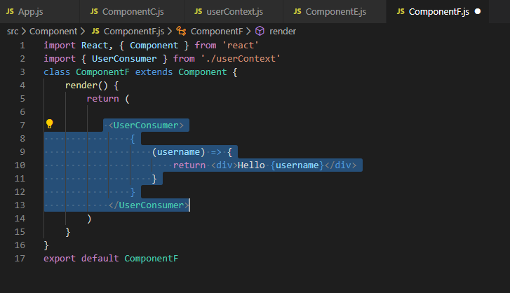

Important points about Context api-

1. We can set default value to the context and it can be set while creating context itself by passing value as an argument in createContext method.

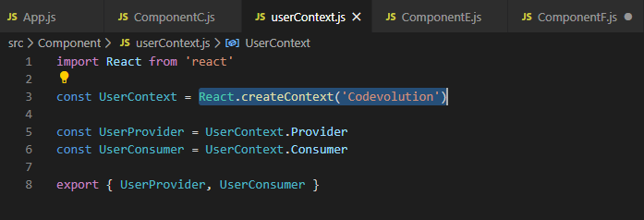

This value can be directly use in Component F, no need to provide value through UserProvider in App Component.

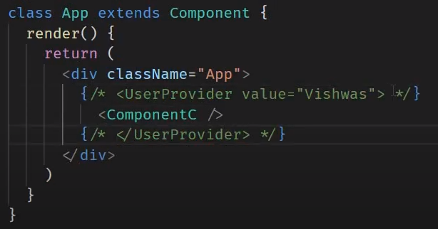

If we uncomment above code, then Userprovider will override the default value.

Another way to consume by using contextType():

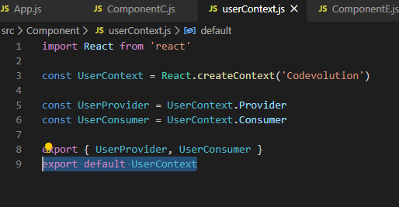

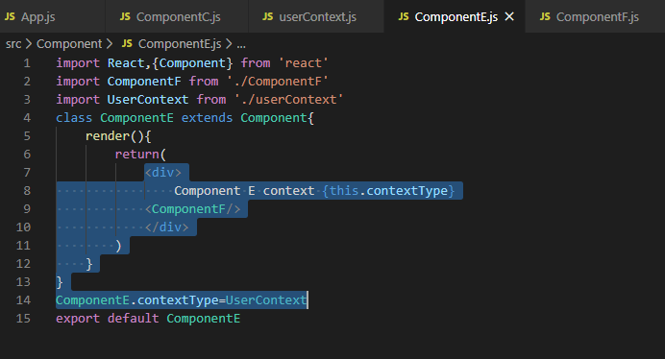

Limitation of contextType:

1. It only works with class component.

2. Through contextType we can only subscribe to a single context using contextType. Cannot read more than one context.

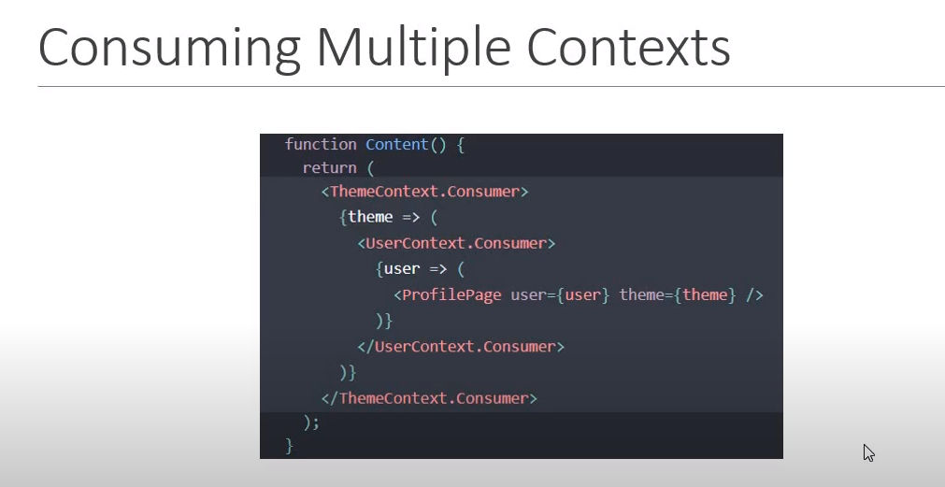

# HTTP and React

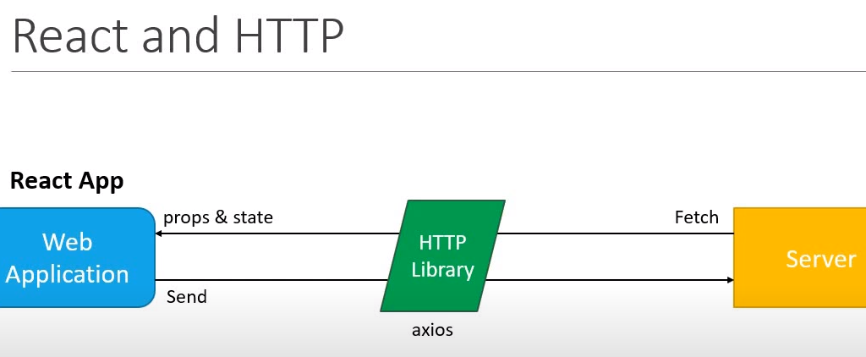

## Http GET request

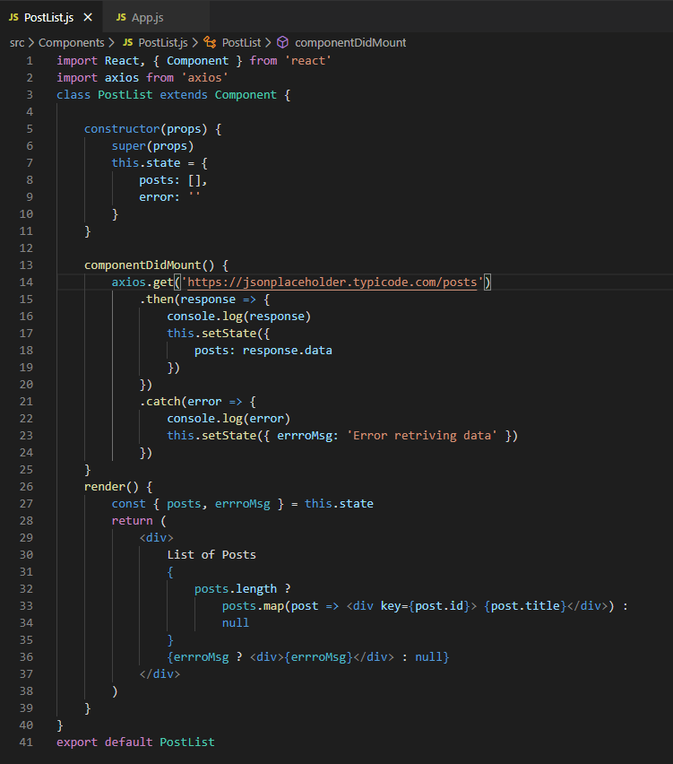

## HTTP POST request

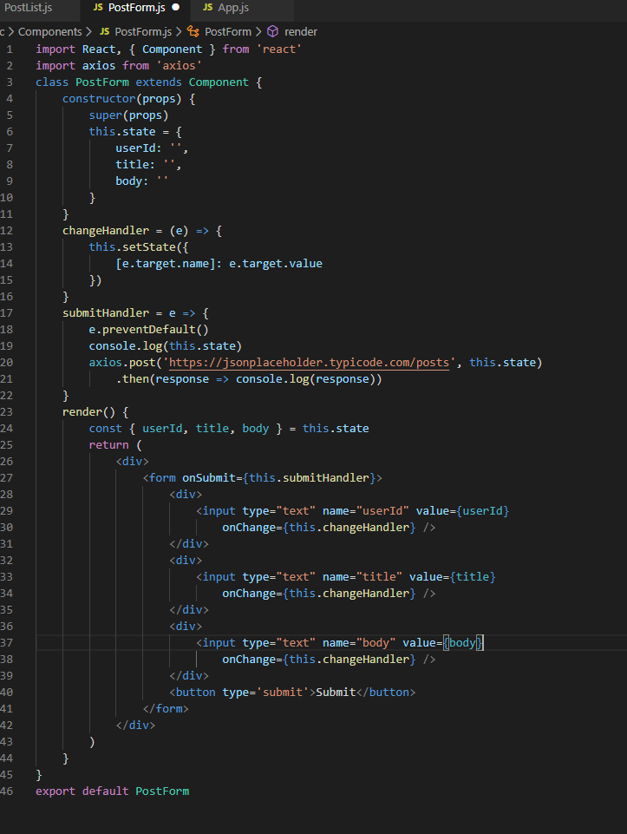

Web-pack is a tool which allows to bundle all assets like js , css, and so on into a single or into a single files which then get imported in HTML pages, additionally it not only bundles stuff it also is able to transform it so ,ex compile SAS code, can load a lot of plugins into webpack as per our requirement.

ES6 is used to write react js code but ES6 is not supported by all native browsers so will use babel which is a transpiler that transpile es6 to es5 by loading babel plugin into webpack.

Npm init: setting up a new project managed by NPM that means can use NPM to pull in packages and so on.

Package.json:- responsible to manage dependencies.

npm install react react-dom –save:- to install react dependencies that are required in prod deployment.

npm install webpack webpack-dev-server babel-loader babel-preset-env babel-preset-react babel-preset-state-2 --save-dev:- to install babel and webpack

--save-dev used to install only dev dependency and it don’t install production dependencies.

Links for react:

Javascript Refresher

https://www.youtube.com/watch?v=vEROU2XtPR8

React Crash Course

https://www.youtube.com/watch?v=sBws8MSXN7A

Create Sample React App –

https://github.com/facebook/create-react-app

Understanding Redux –

https://www.youtube.com/watch?v=DiLVAXlVYR0&list=PL6gx4Cwl9DGBbSLZjvleMwldX8jGgXV6a

How Browsers Work

https://www.html5rocks.com/en/tutorials/internals/howbrowserswork/#The_browsers_we_will_talk_about

What is babel

https://www.youtube.com/watch?v=t8HBL17uhBo

What is eslint

https://www.youtube.com/watch?v=qhuFviJn-es

What is webpack

https://www.youtube.com/watch?v=5zeXFC_-gMQ

Set up react using webpack and babel

https://www.valentinog.com/blog/react-webpack-babel/

Using eslint

http://www.hackingwithreact.com/read/1/39/linting-react-using-eslint-and-babel

Structuring React projects

https://survivejs.com/react/advanced-techniques/structuring-react-projects/

One of the best resources for react is their official documentation:

https://reactjs.org/tutorial/tutorial.html

this is links may help u for better understanding